**CRM Application For Jewel Management**

**College Name: CHIKKANNA GOVT ARTS COLLEGE**

**College Code:bru06**

**TEAM ID: NM2025TMID26240**

**TEAM MEMBERS:** 04

**Team Leader Name:** ANGEL.B

* **Email:**rrajaraj783@gmail.com

**Team Member1:**DHANUSHA.S

* **Email:** sdhanusha62@gmail.com

**Team Member2:** SIVITHA.M

* **Email:** sivitham0709@gmail.com

**Team Member3:**SWETHA.R

* **Email:** swetharaj105@gmail.com

**INTRODUCTION**

* Project Overview

A CRM for jewelry management is a Customer Relationship Management software tailored for the jewelry industry to track sales, manage leads, and understand customer buying patterns through detailed profiles and purchase history, ultimately driving personalized marketing, improving customer service, and increasing loyalty and sales.

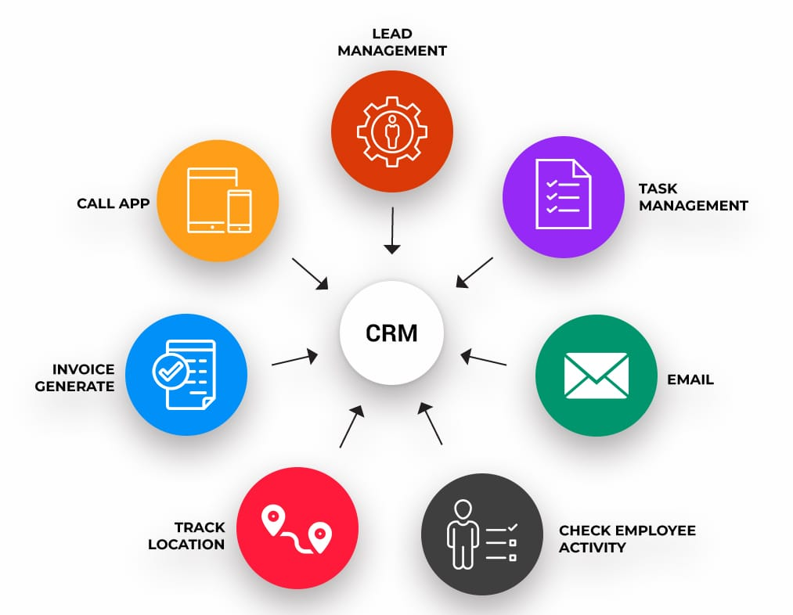

* Purposes

One of the most significant advantages of jewellery CRM systems is the ability to manage customer relationships more effectively. From tracking customer preferences and managing orders to sending targeted marketing campaigns, CRM software provides businesses with valuable insights into customer behavior.

# DEVELOPMENT PHASE

* **Creating Developer Account:**

By using this URL[**-https://www.salesforce.com/form/developer-signup/?d=pb**](https://www.salesforce.com/form/developer-signup/?d=pb)

# 

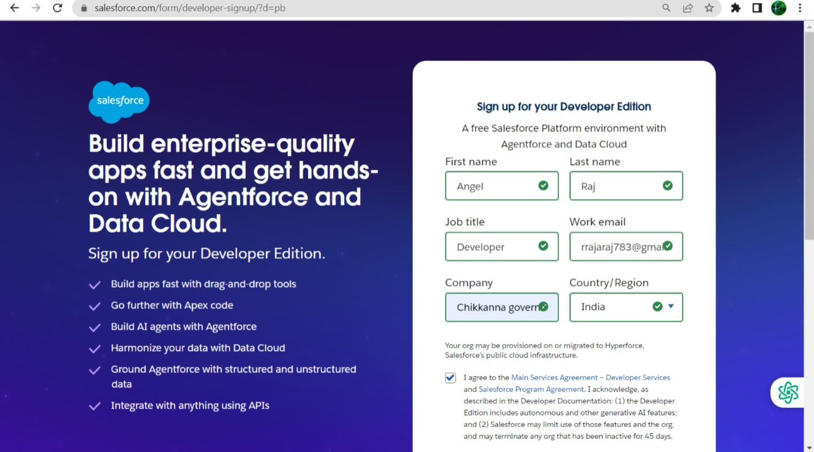

**Object**

* 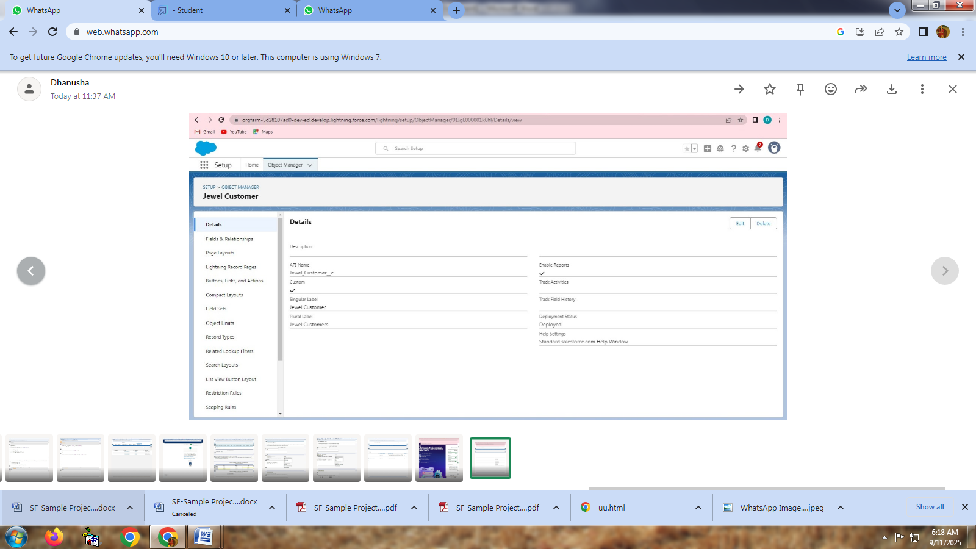Create jewel customer object
* 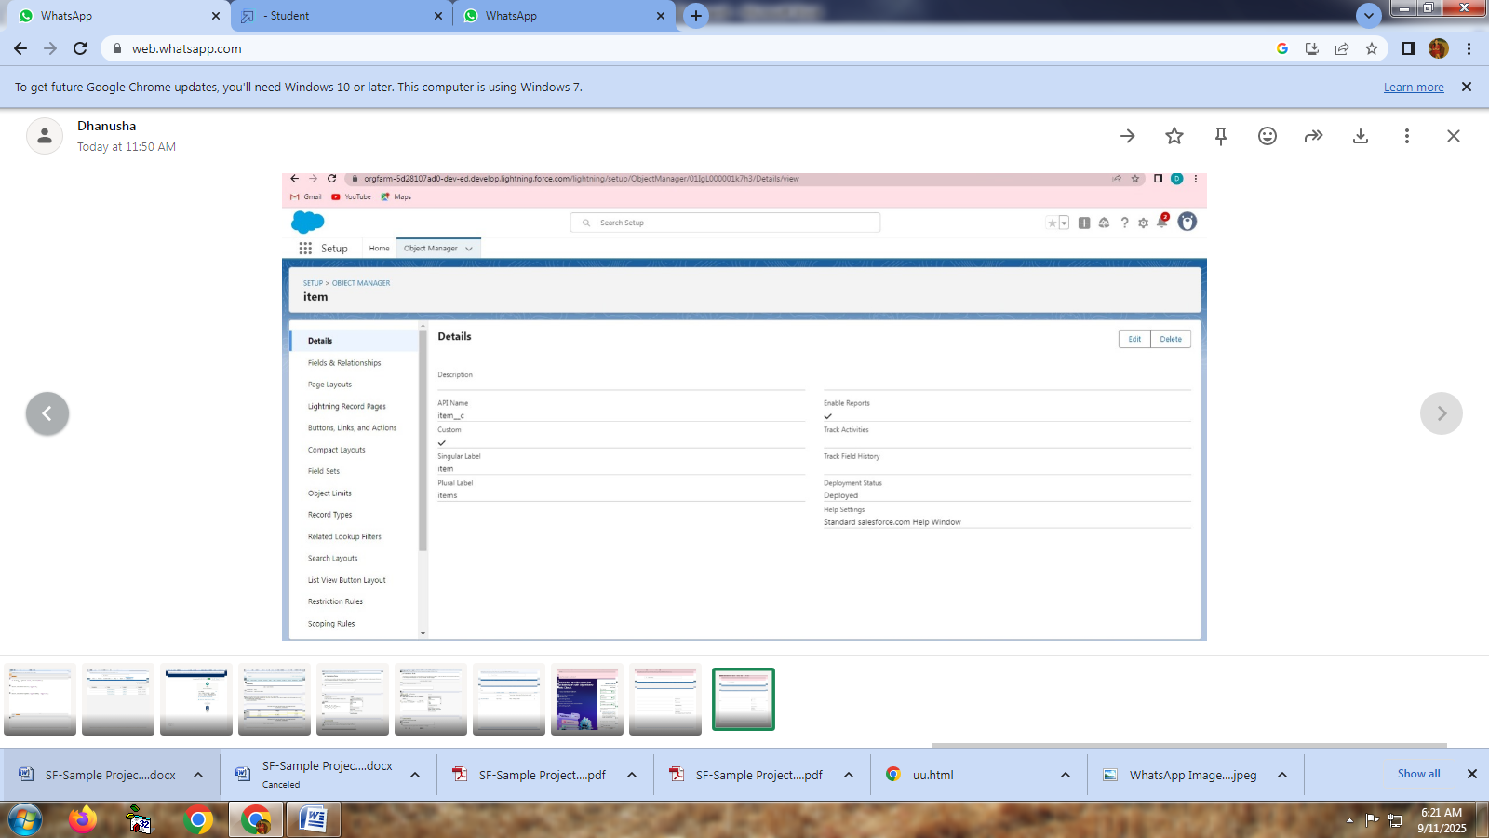create items object
* Create customer order

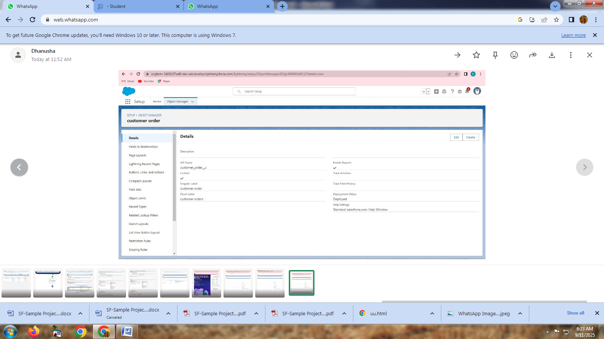

* 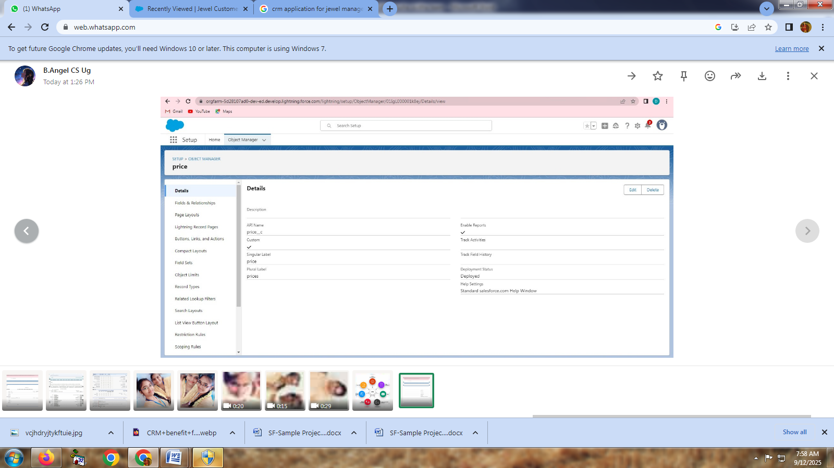Create price
* 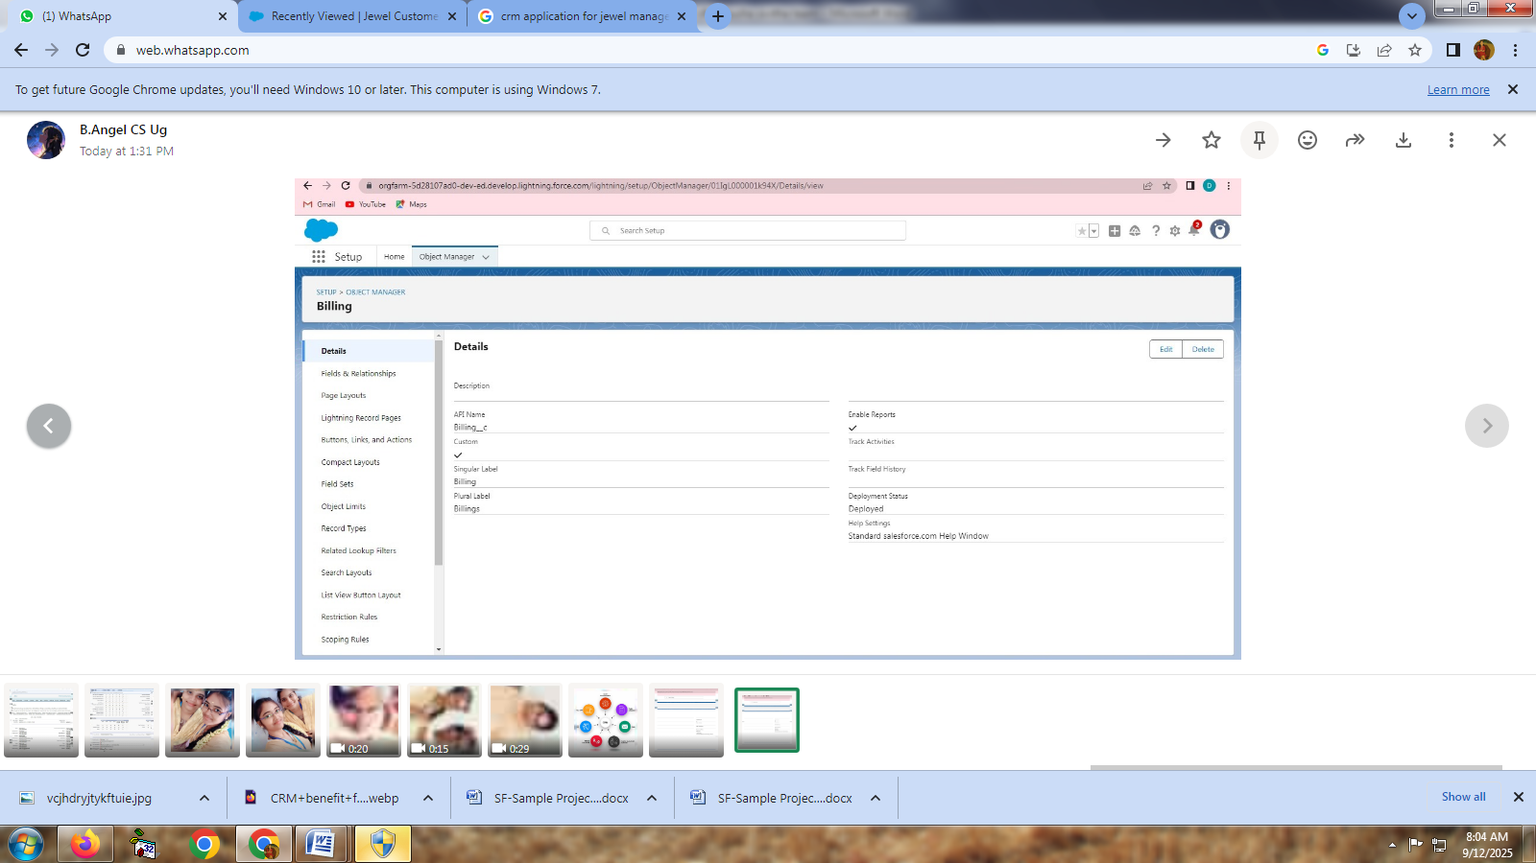Create billing

**Tabs**

* 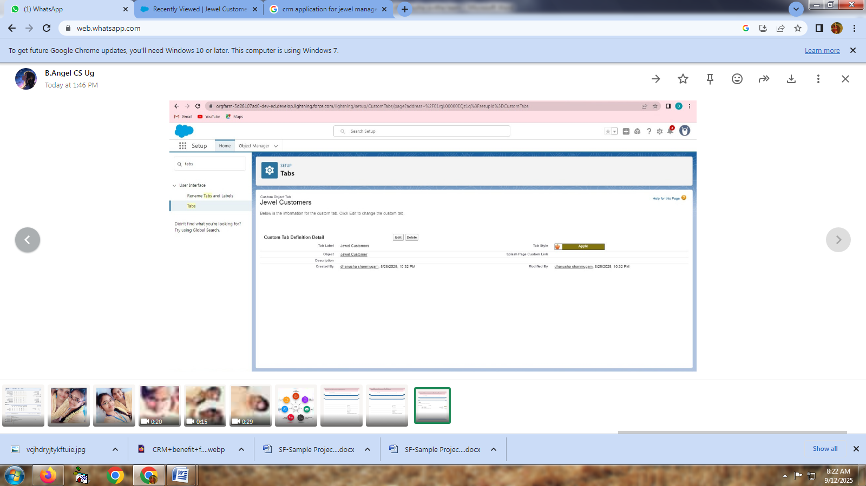Create a tab for Jewel customer
* 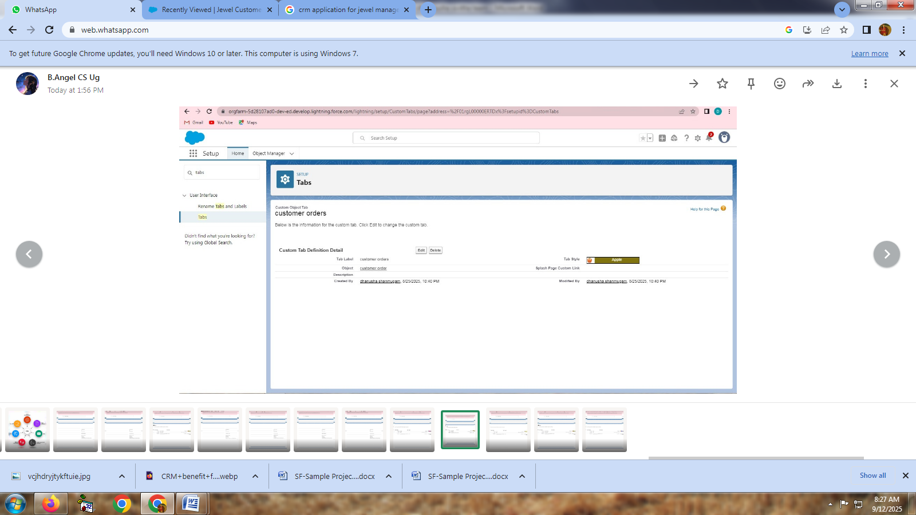Create a tab for Customer order

* Create a tab for price

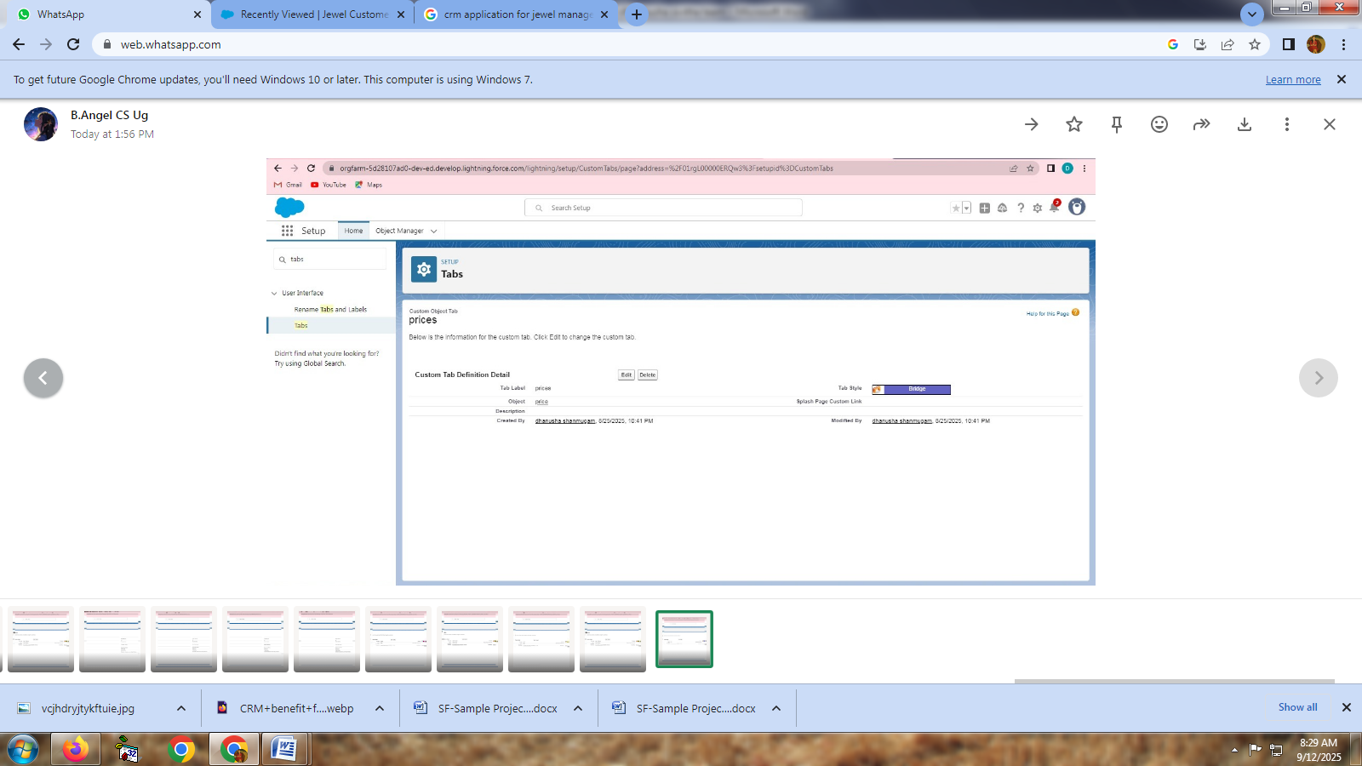

* 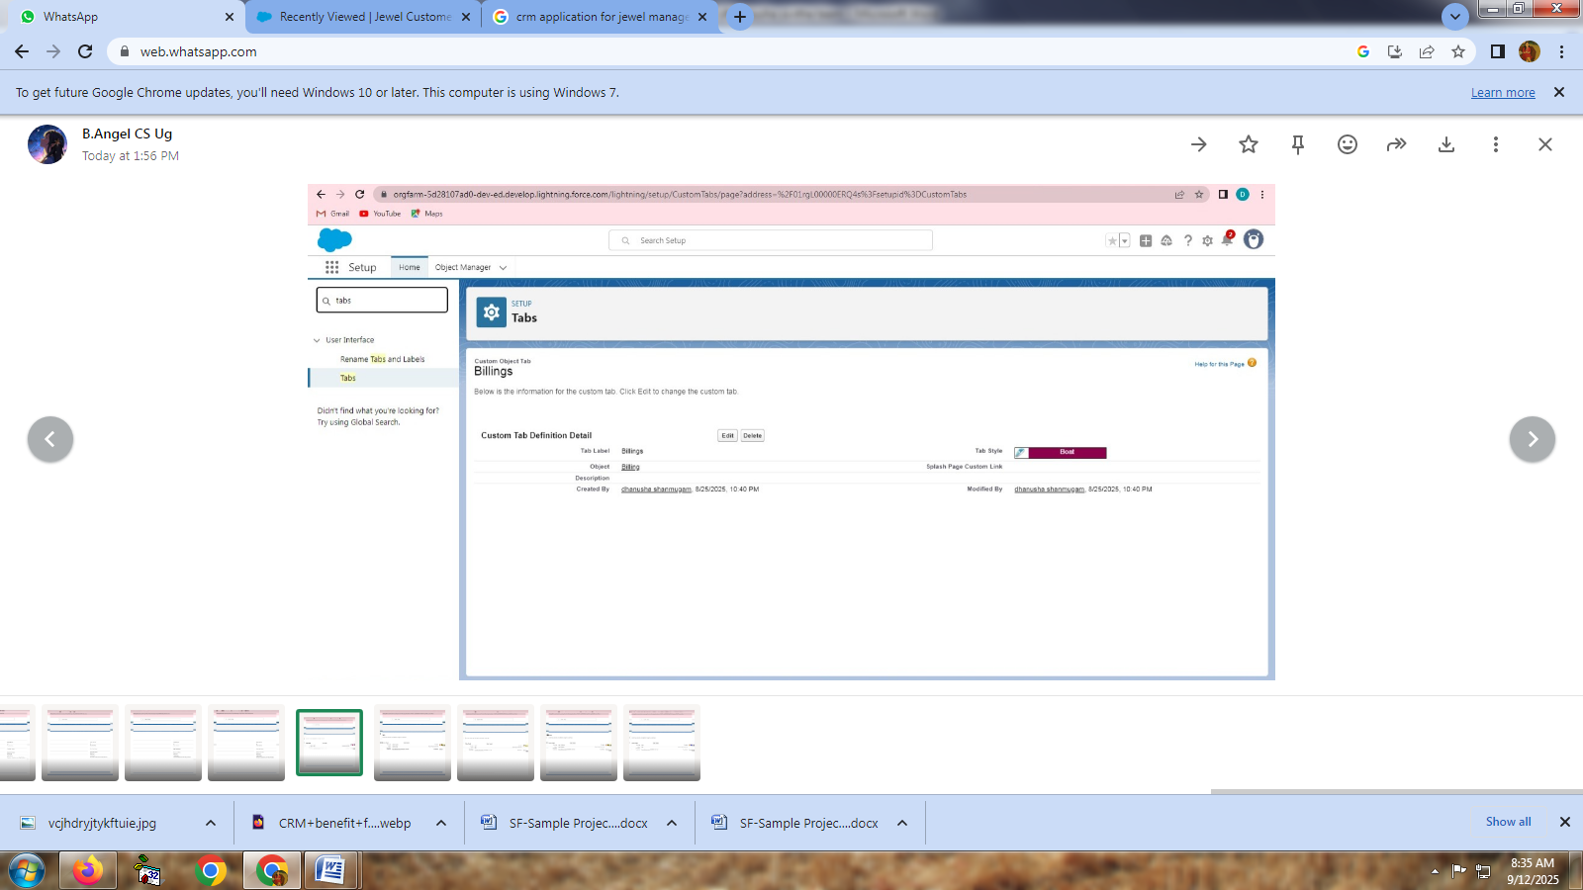Create a tab for billing

**The lightning app**

* 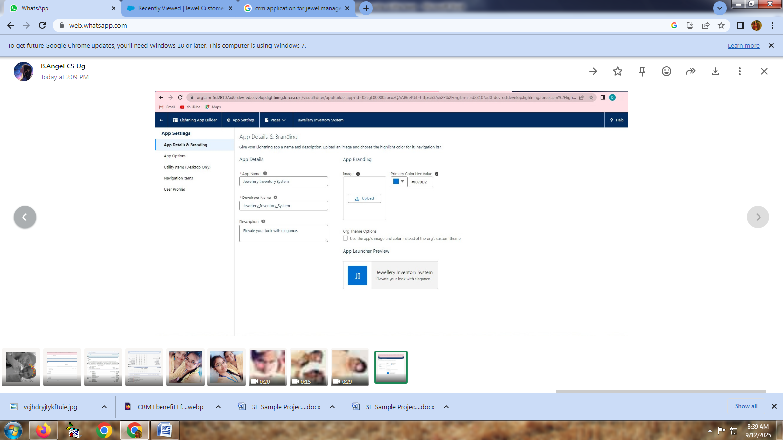Create a lightning app
* Creating Lookup Relationship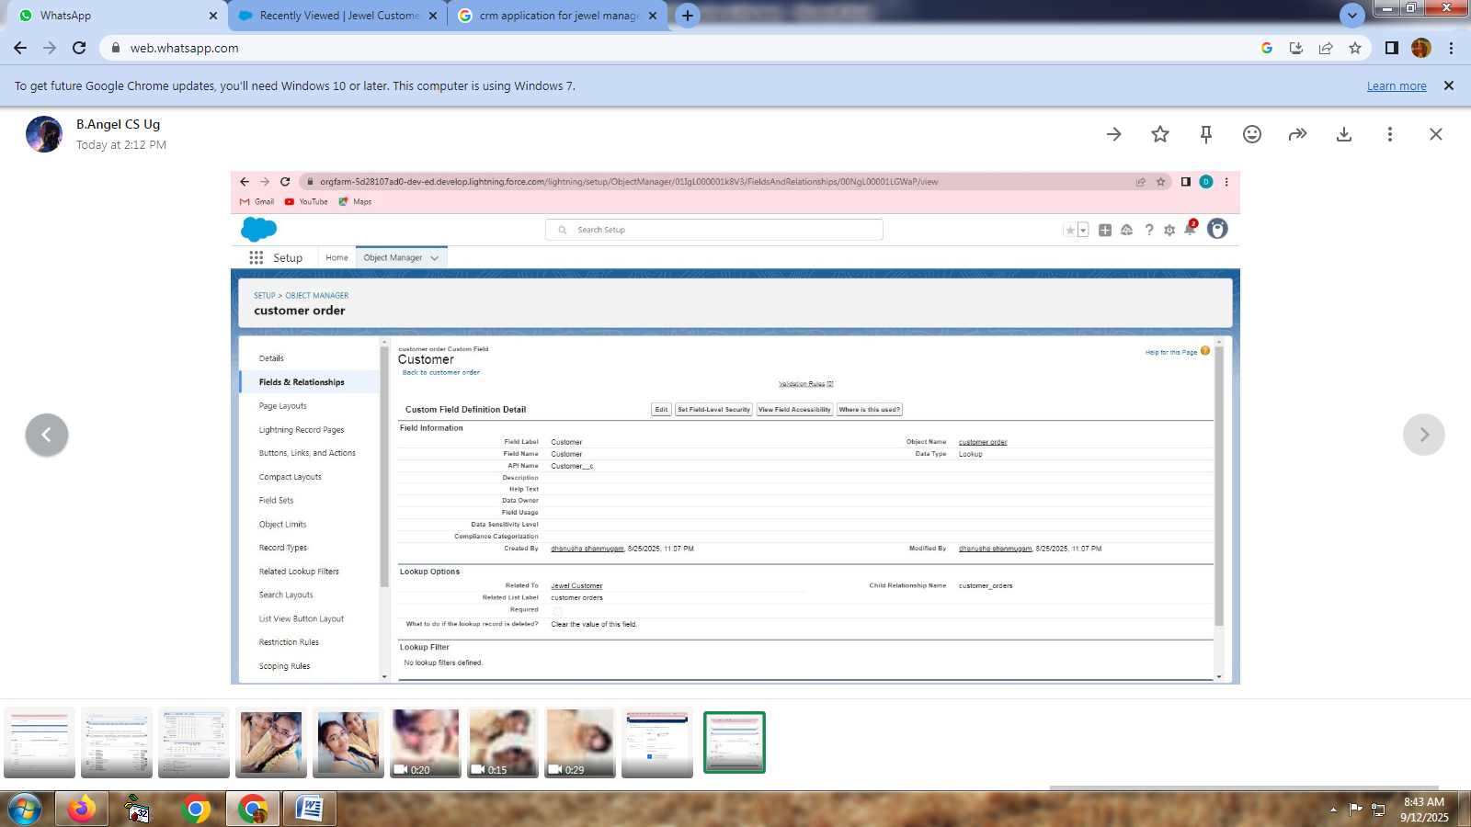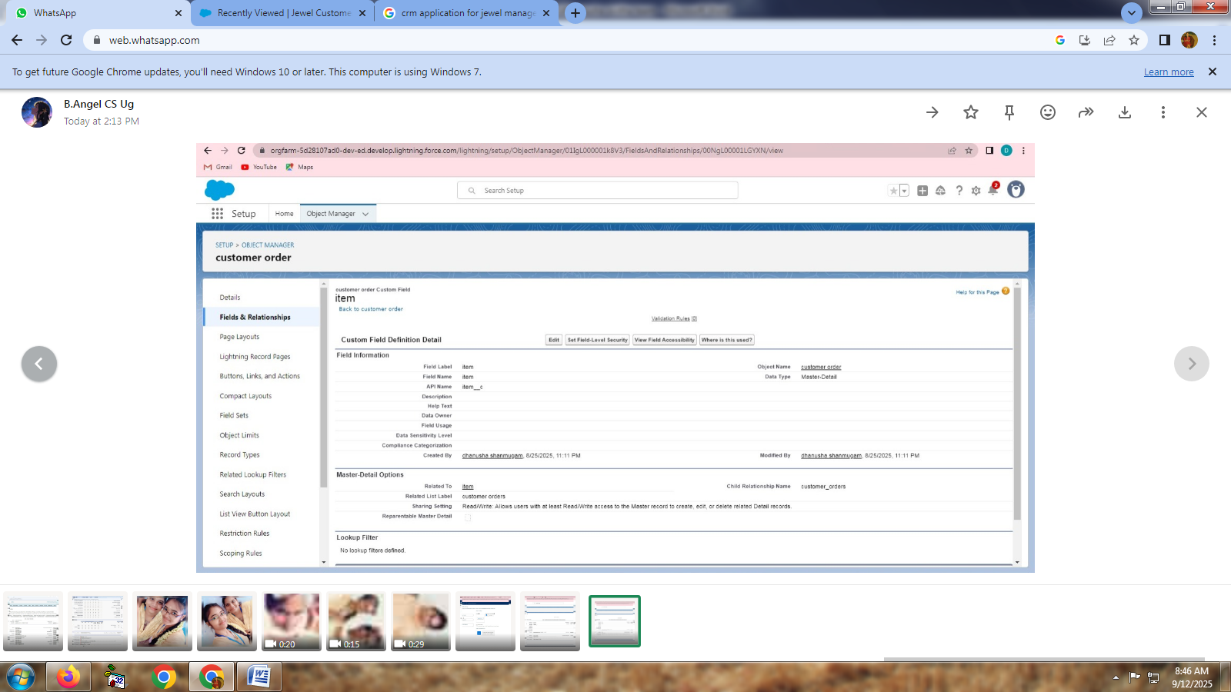
* Creating a Master-Details Relationship

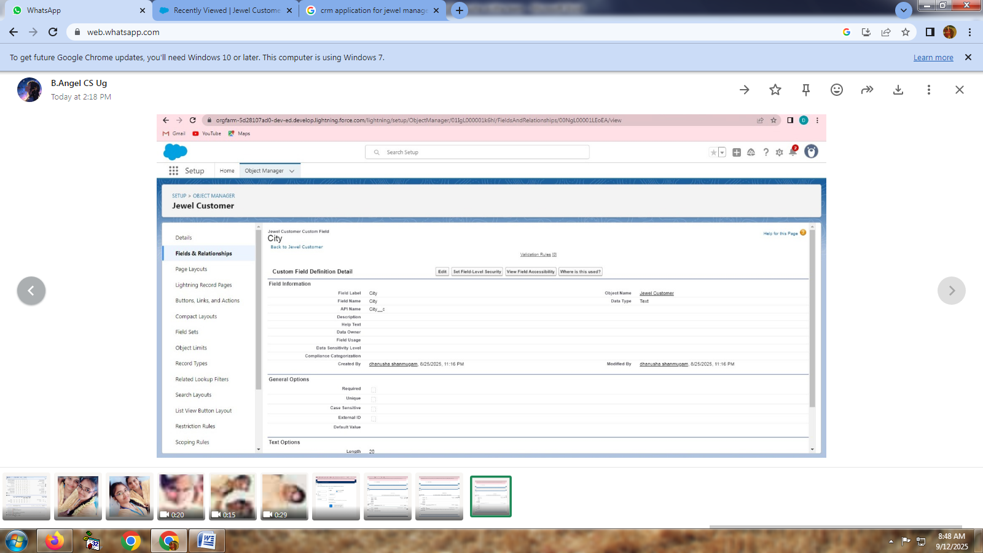

* Creating the Phone field in object Jewel Customer

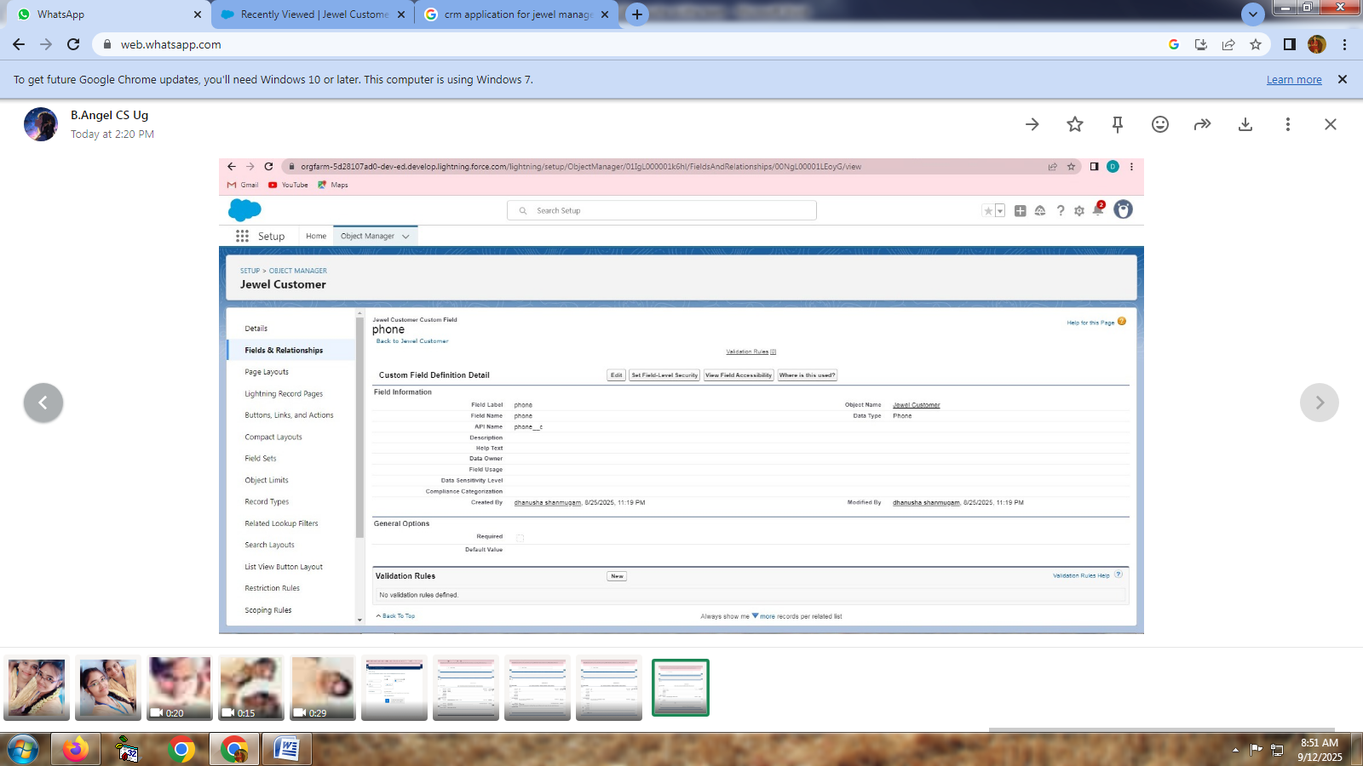

* Creating the Email field in object Jewel Customer

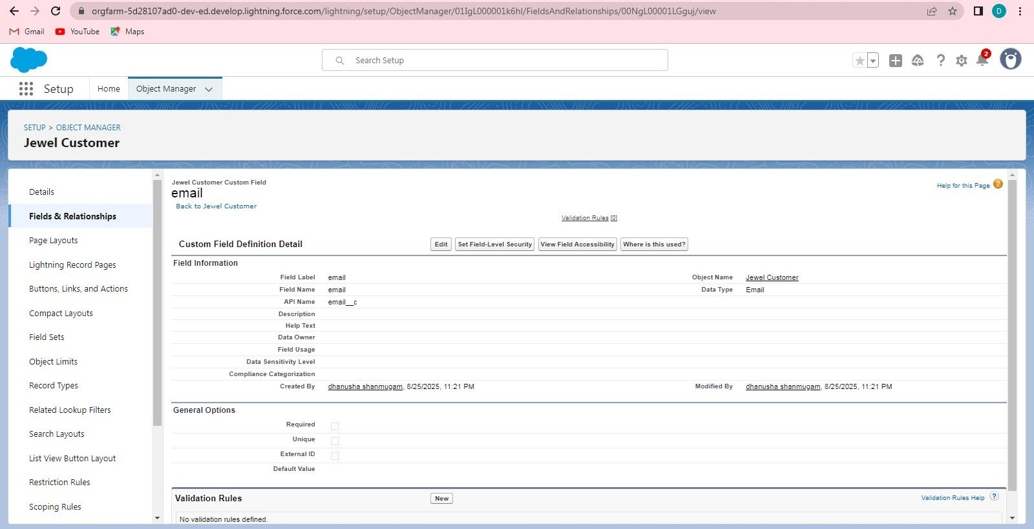

* Creating the number field in Item object

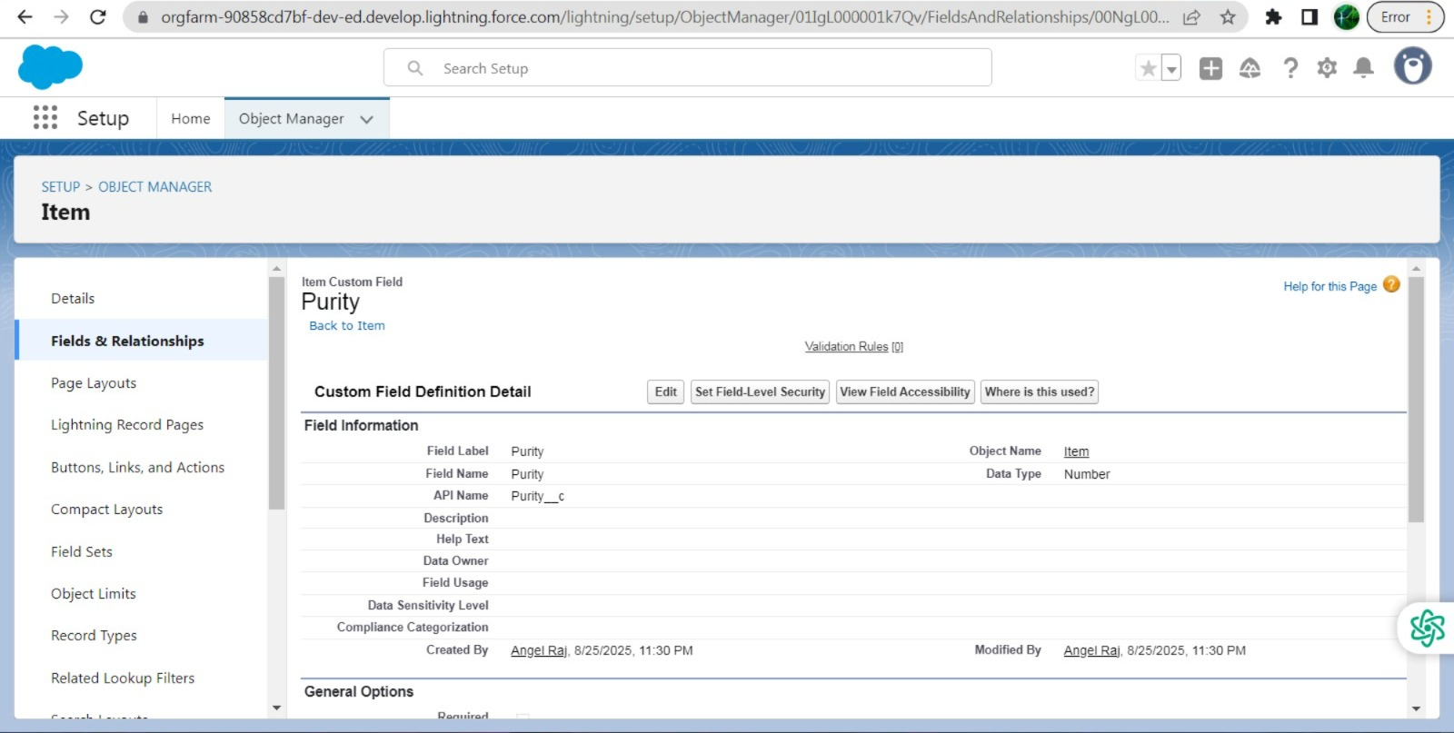

* Creating Pick list Field In Item Object

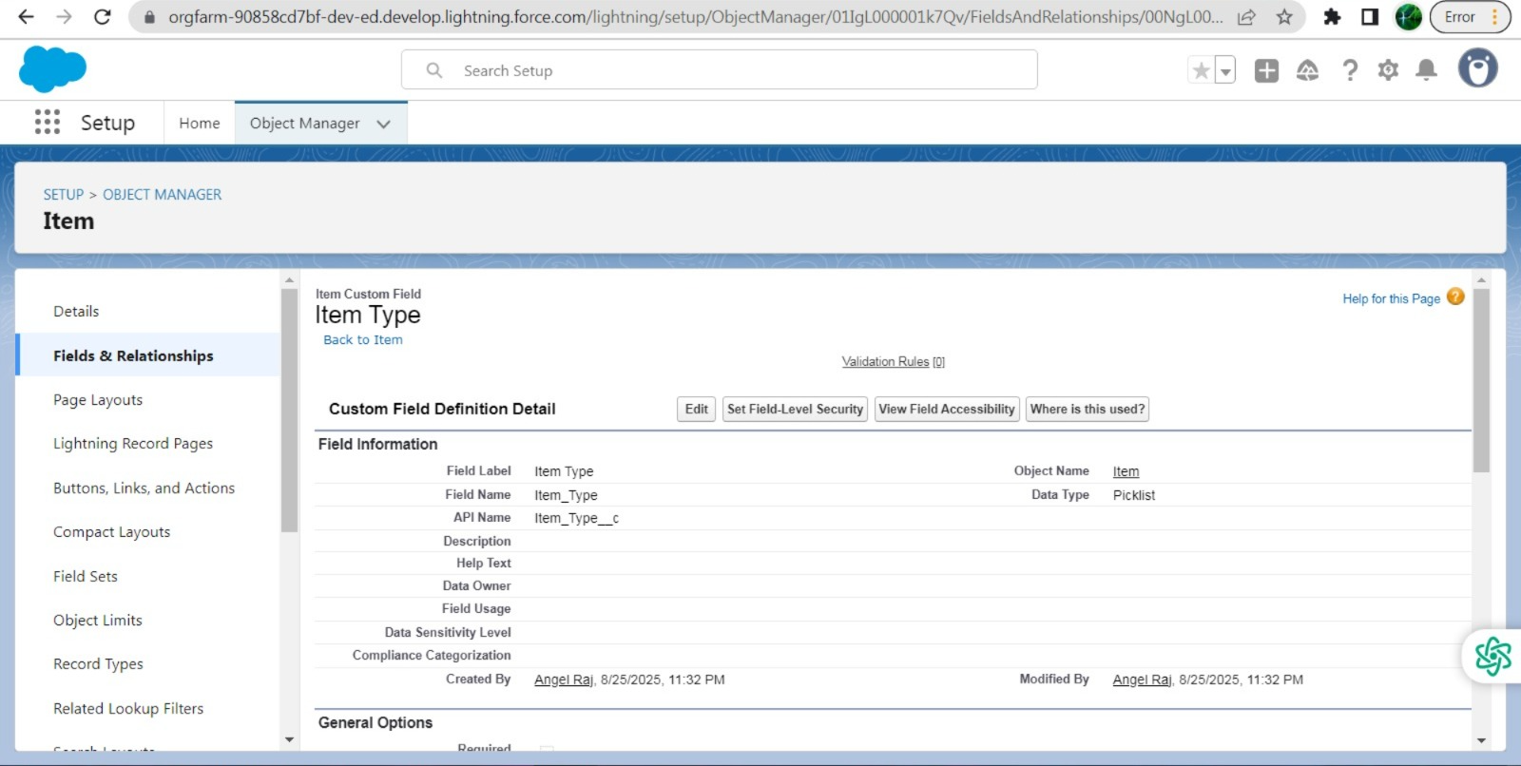

* Creating Currency Field In Price Object

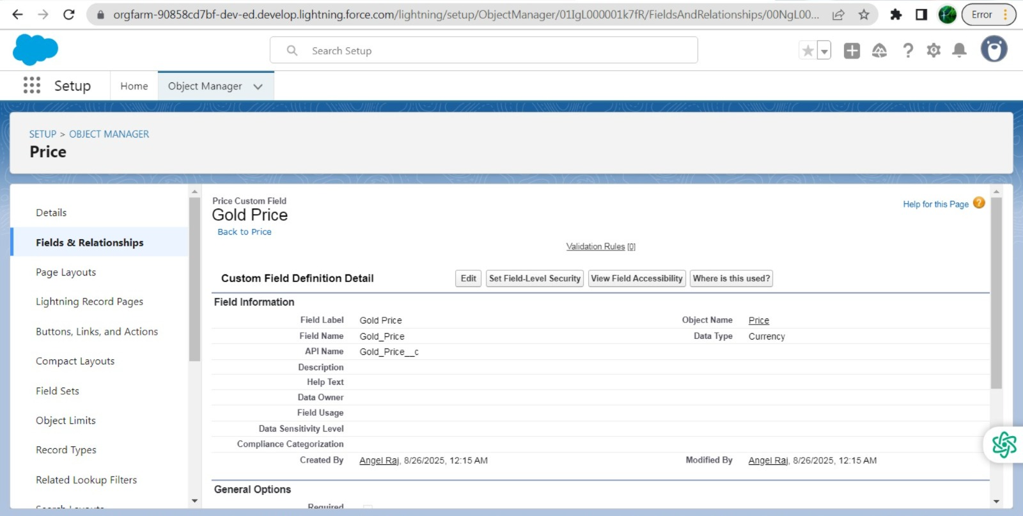

* Creating Formula Field(Cross Object) In Item Object

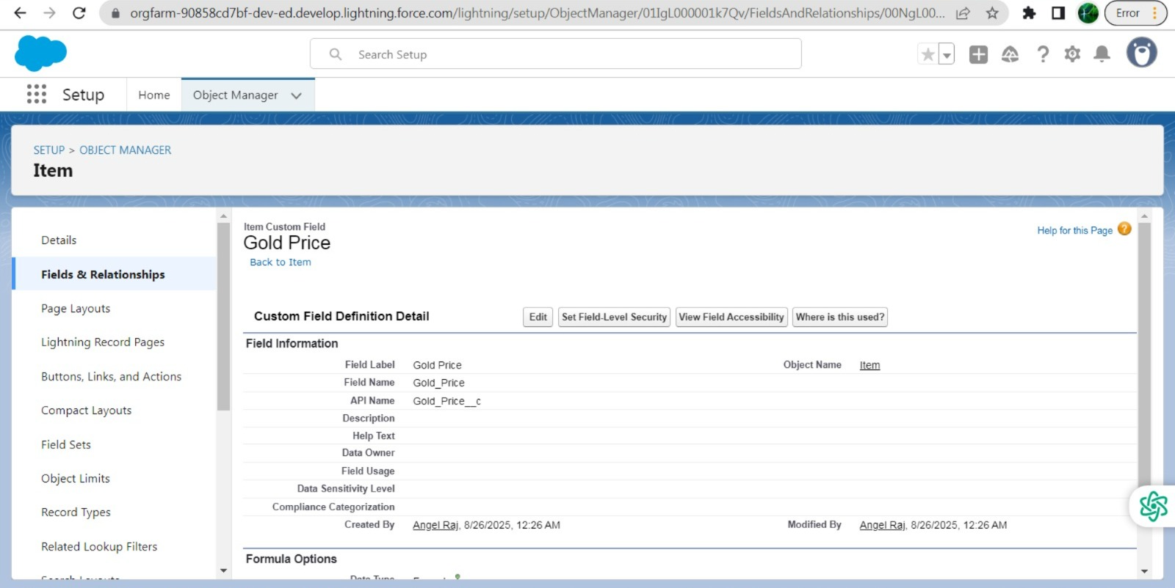

* Creating Remaining Fields In Objects

1. Jewel Customer

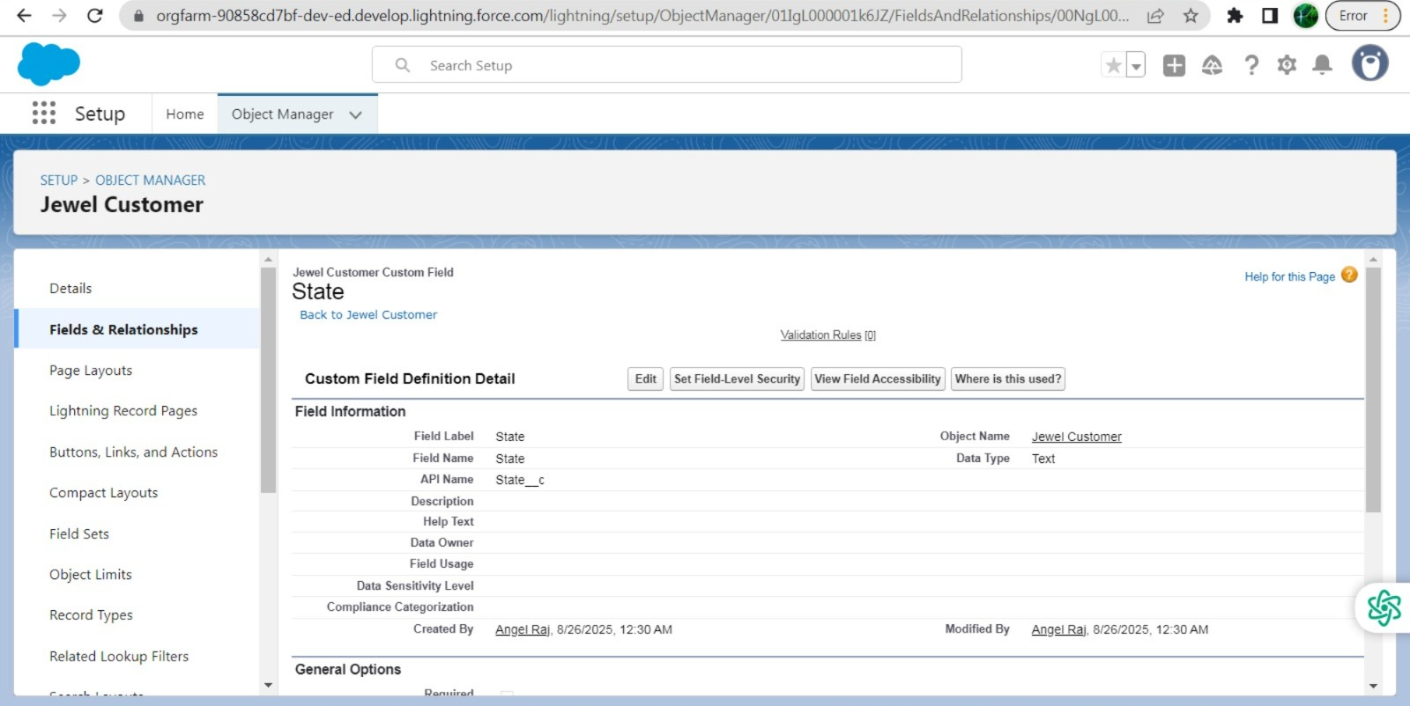

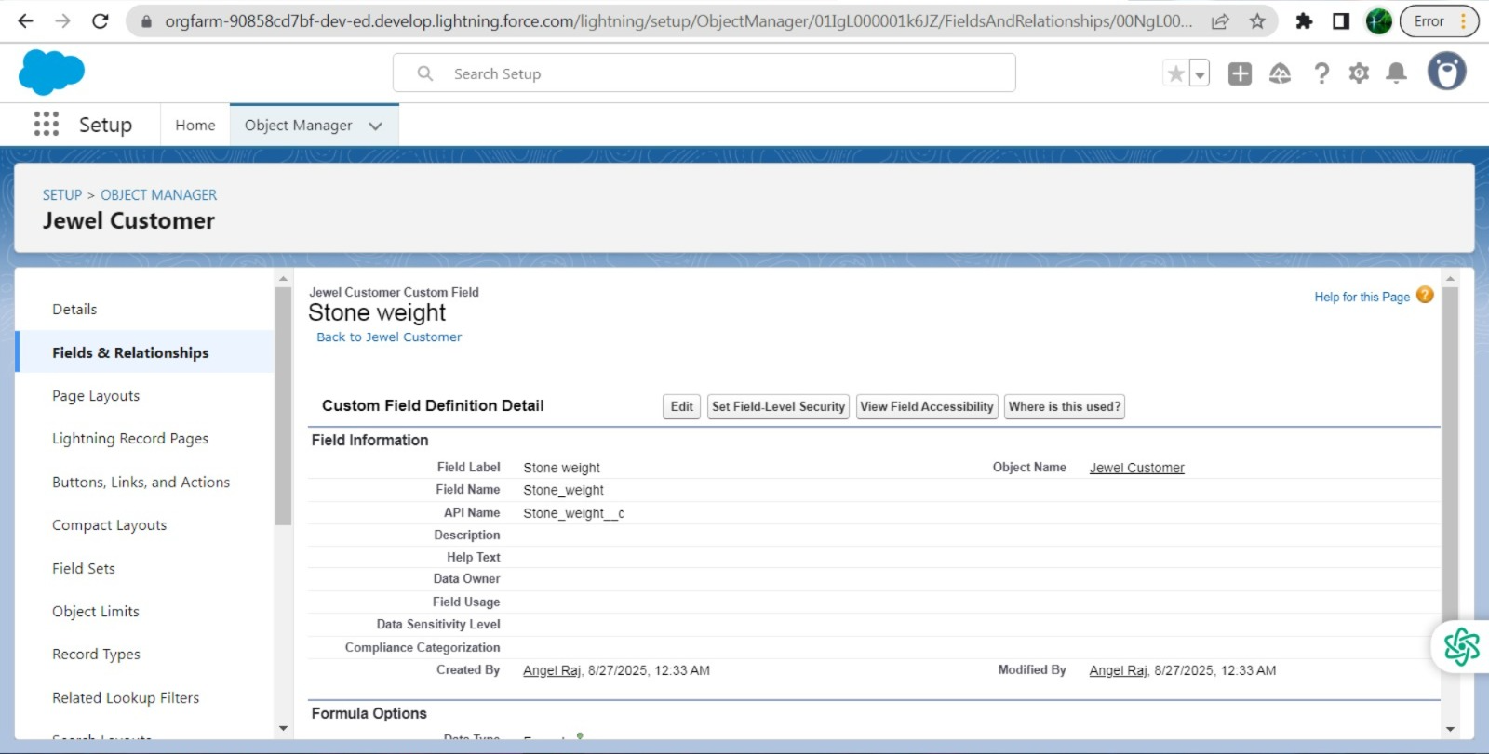

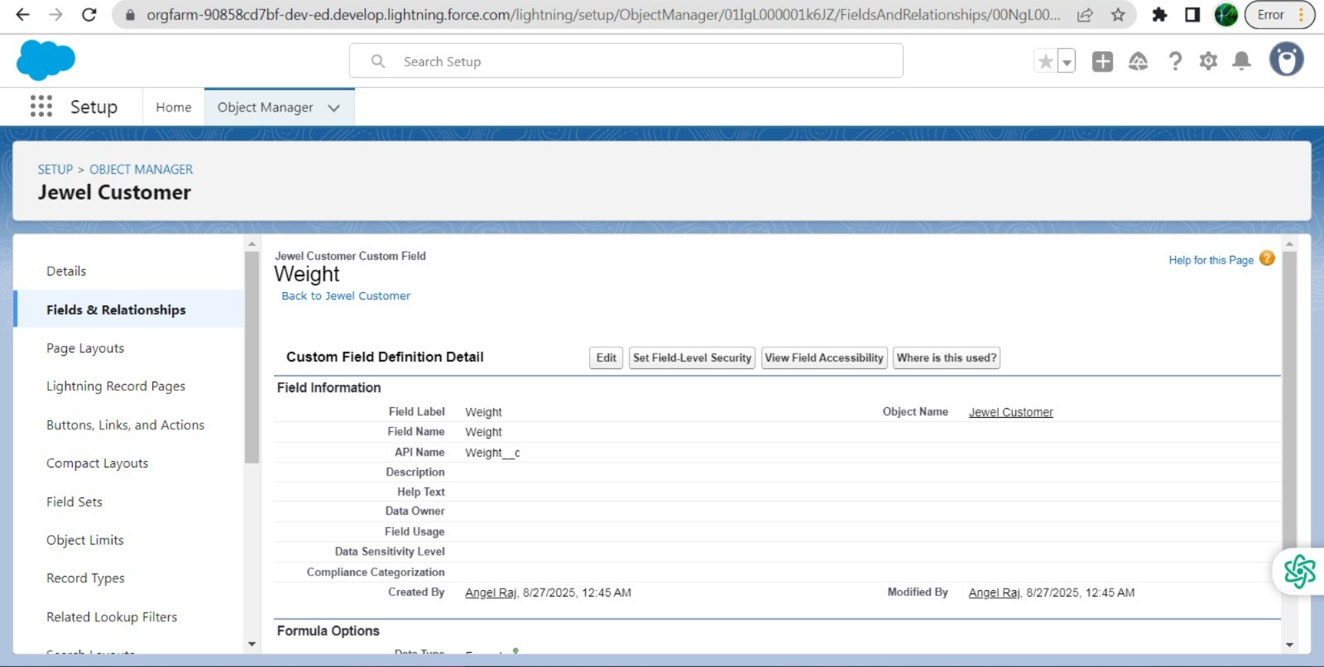

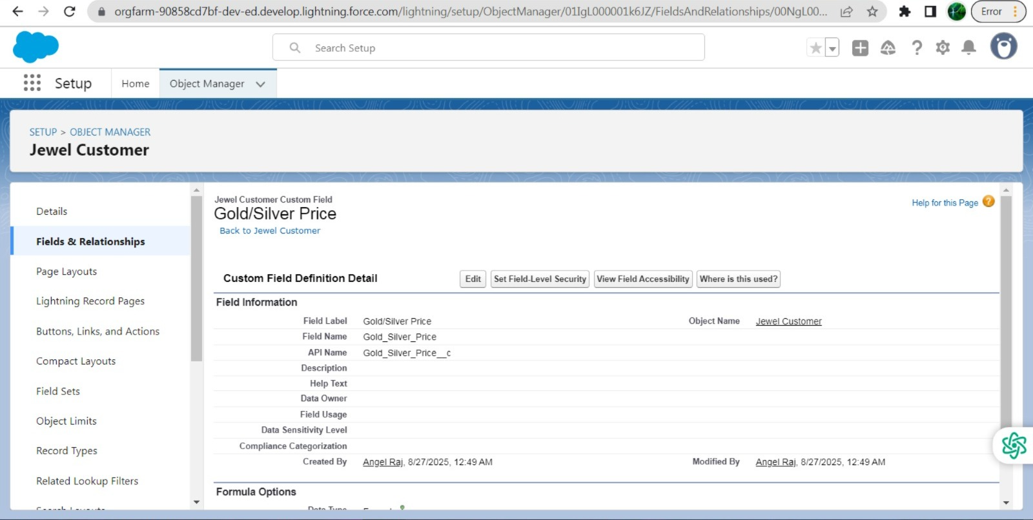

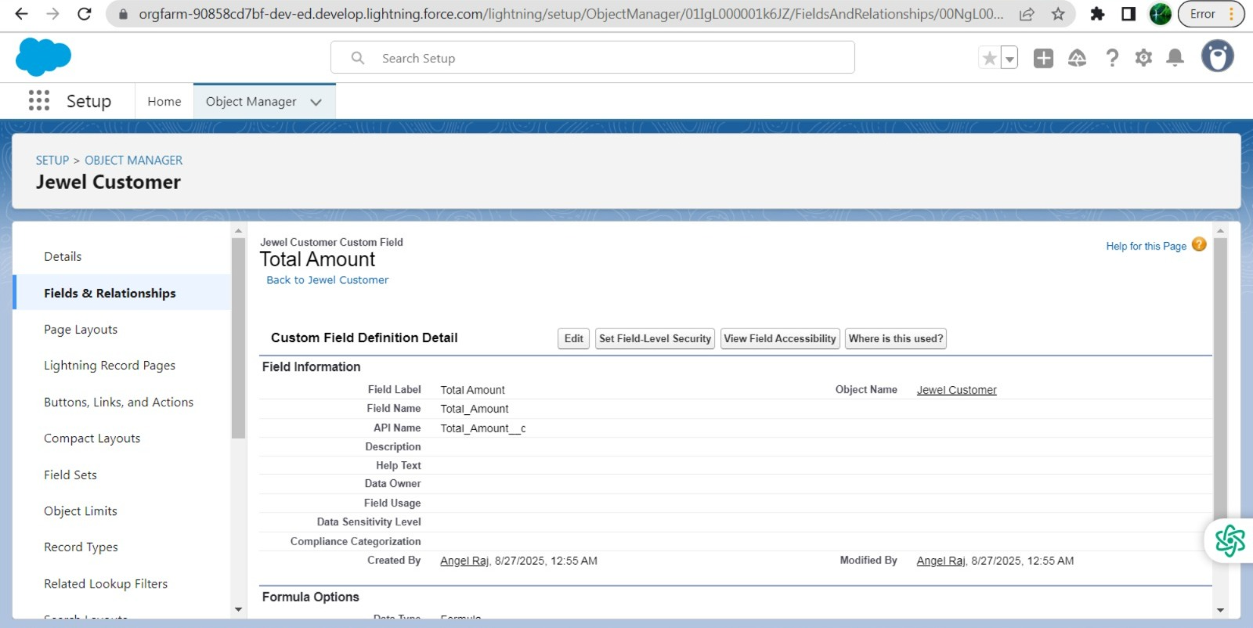

2.Price

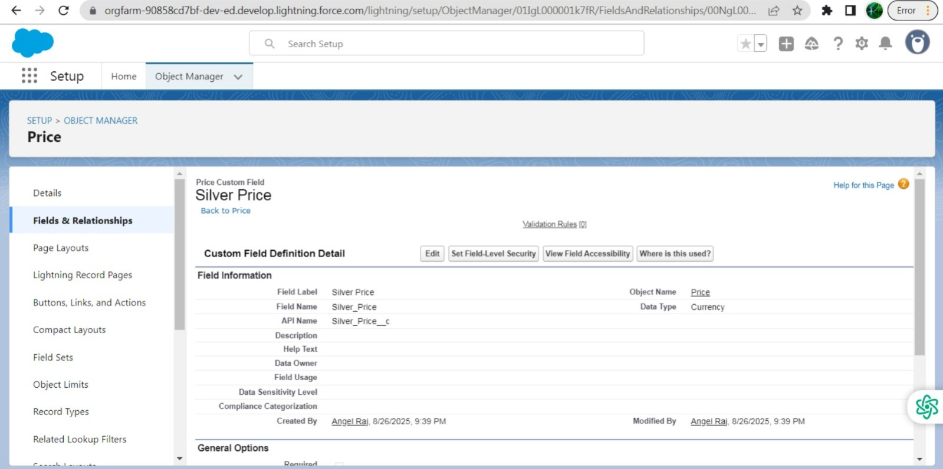

3.Item

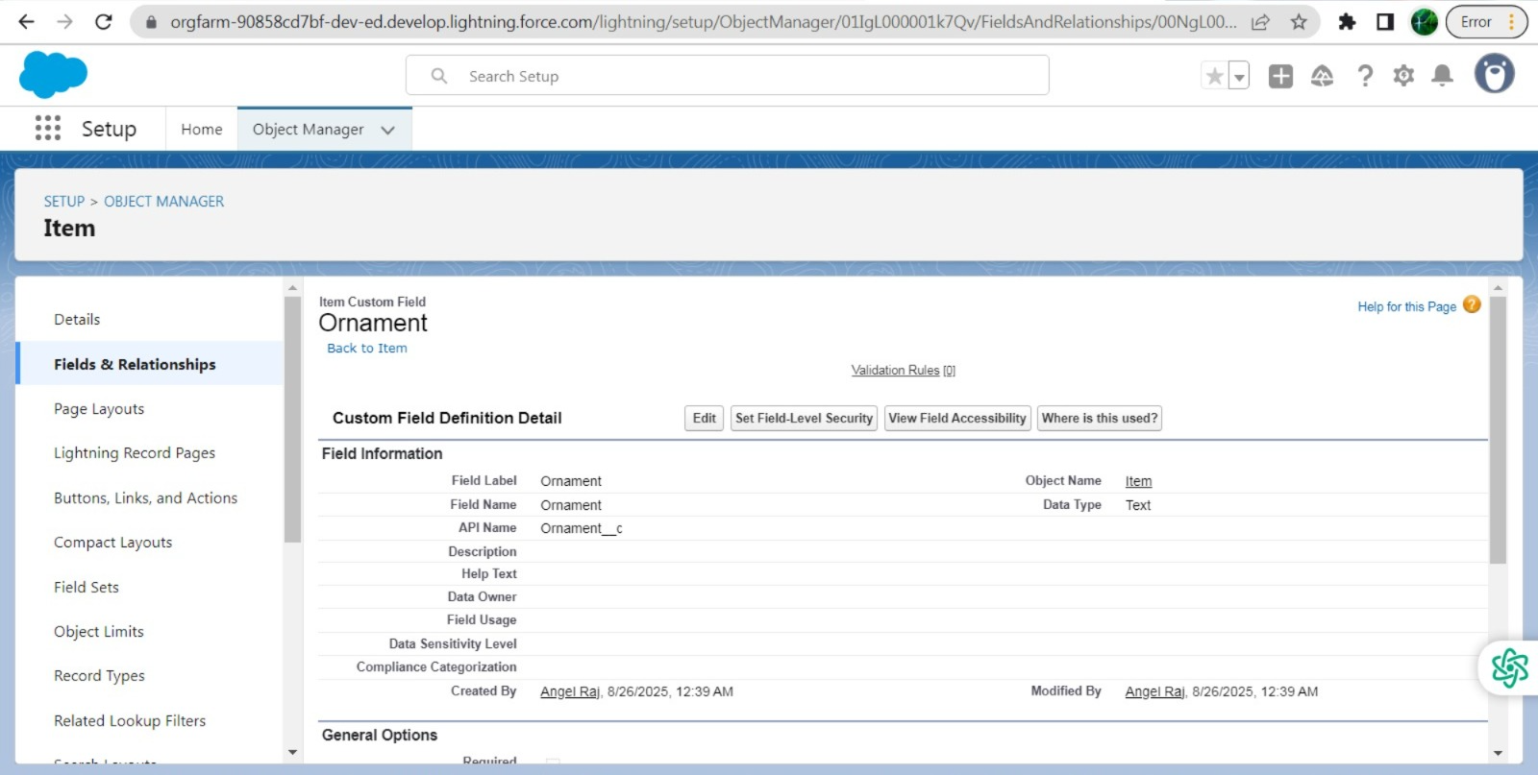

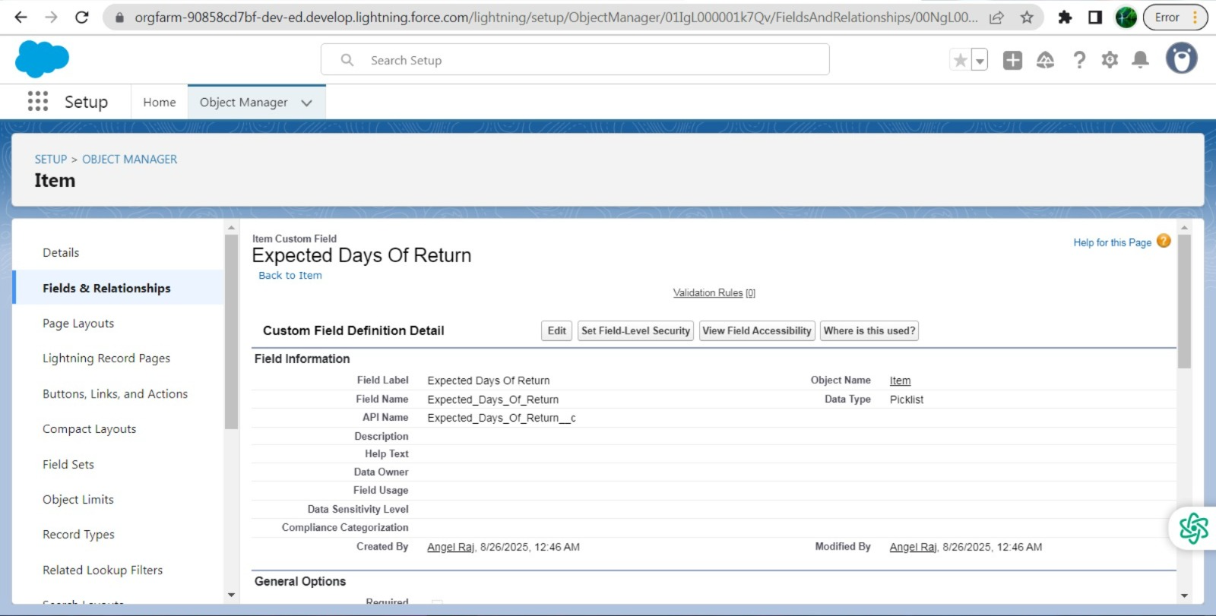

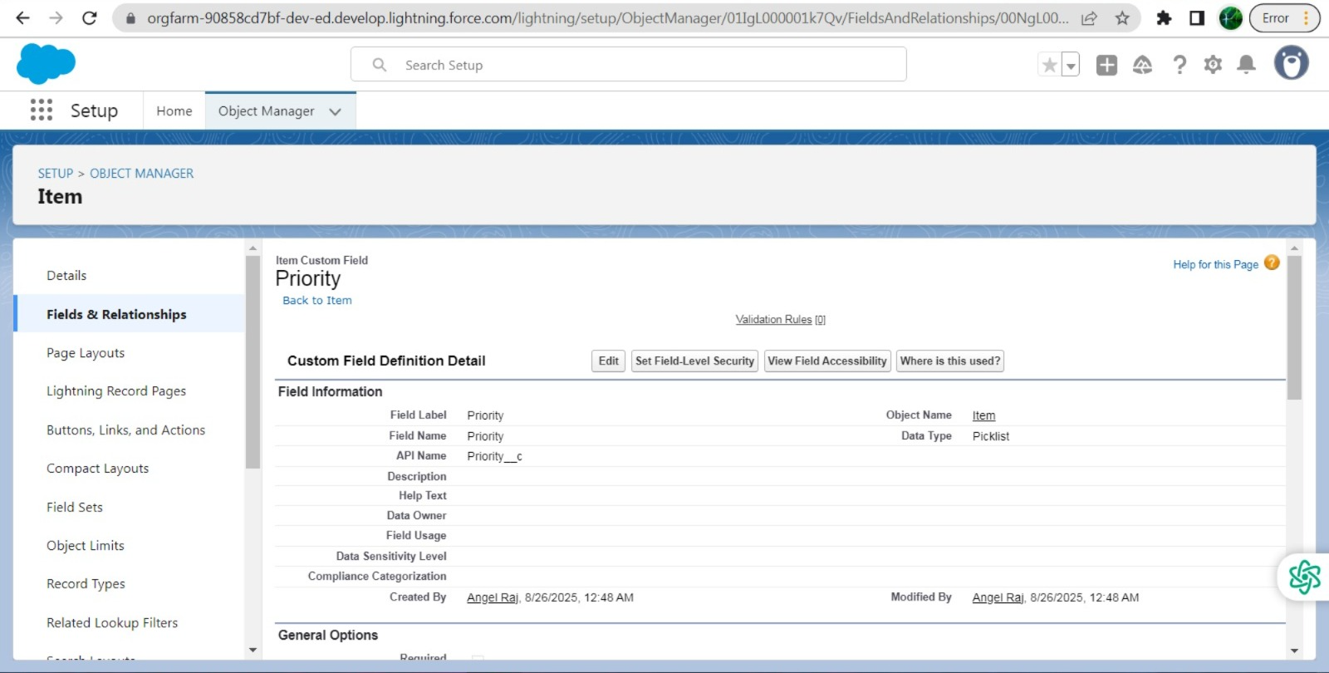

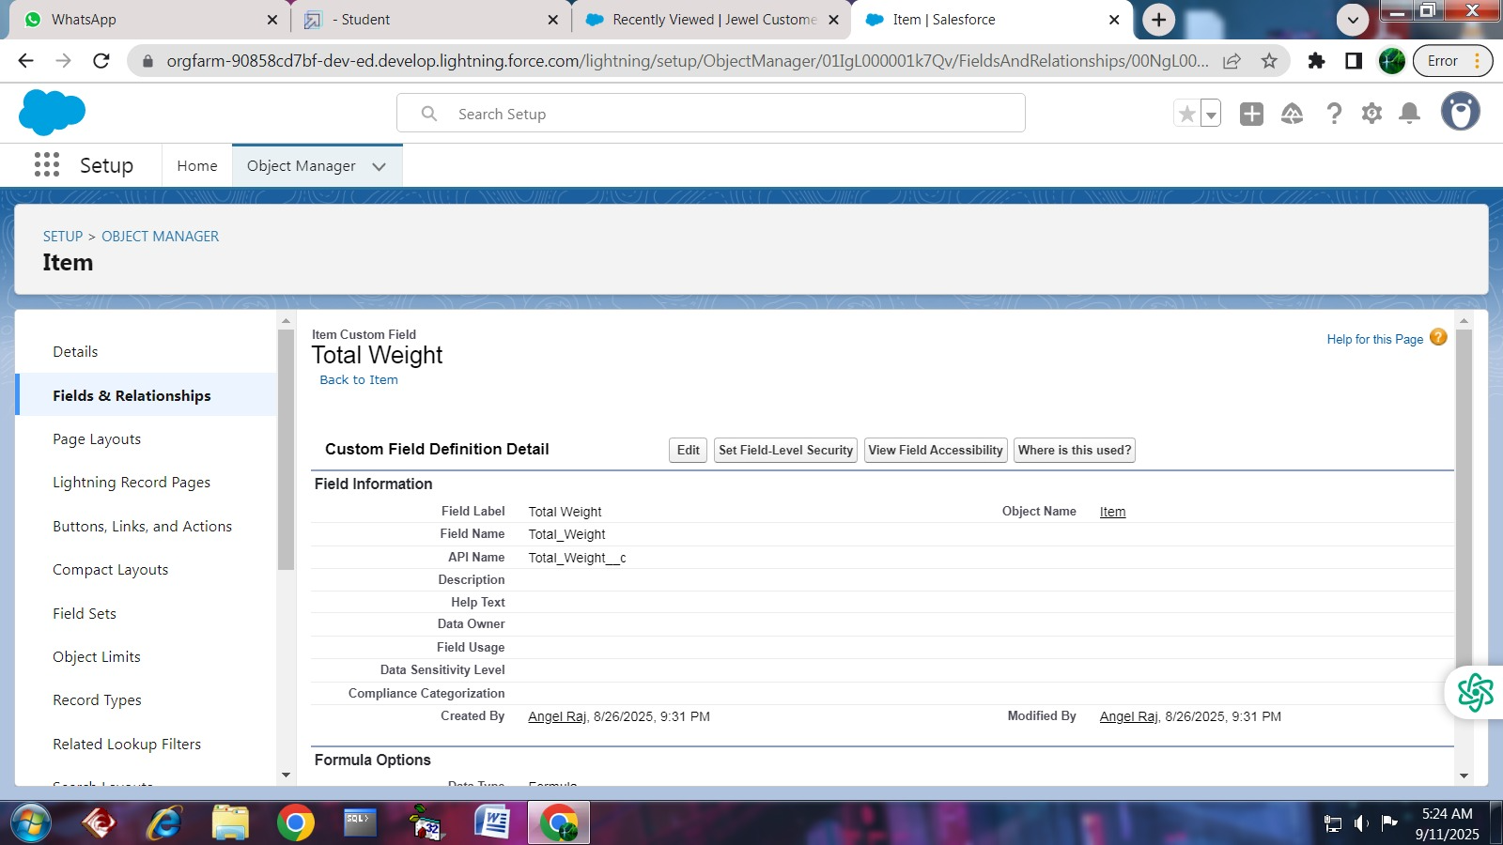

4.Customer Order

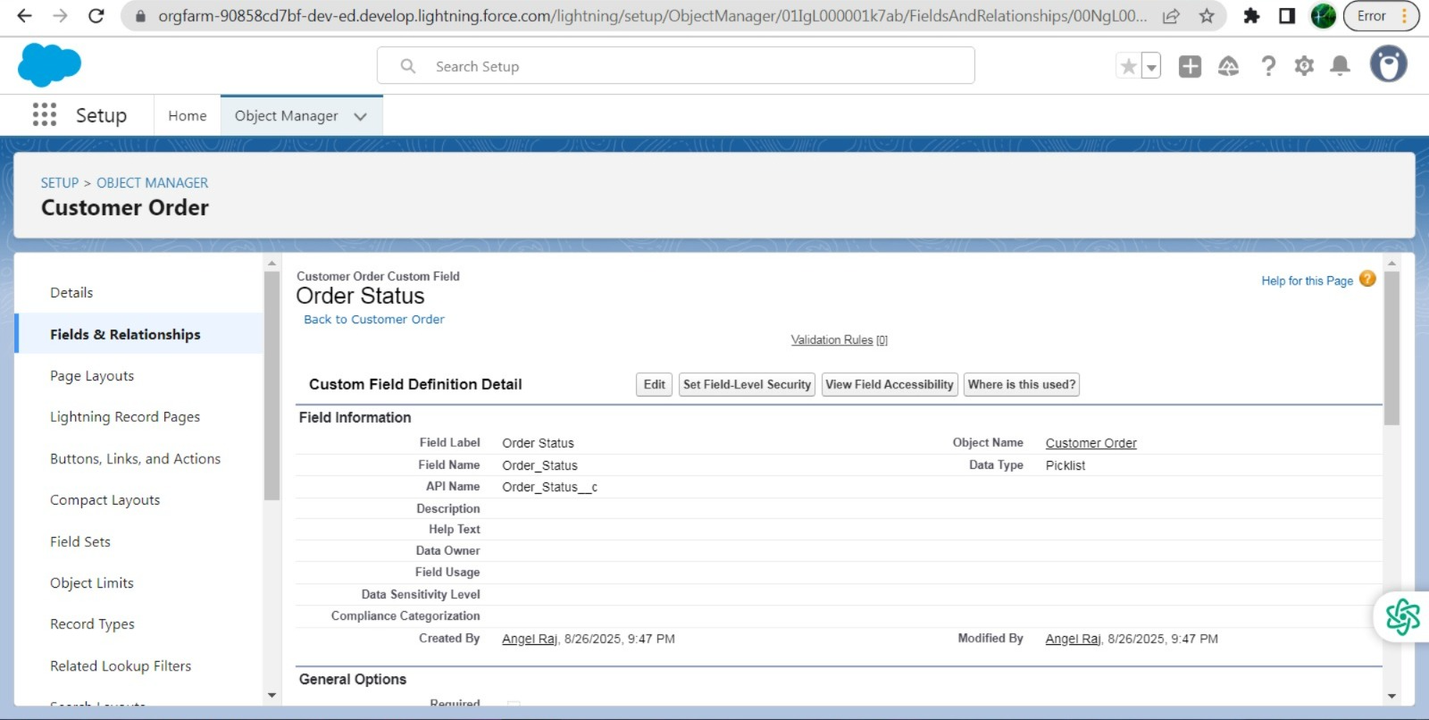

5.Billing

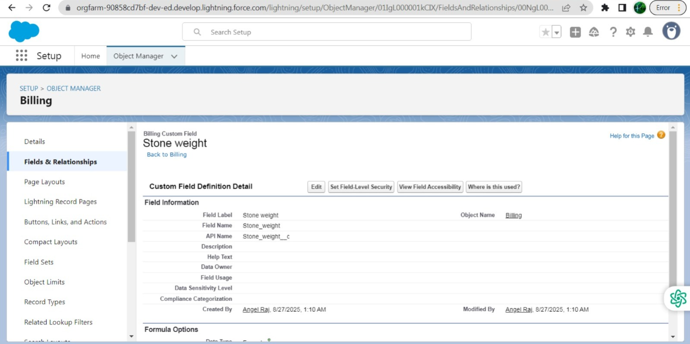

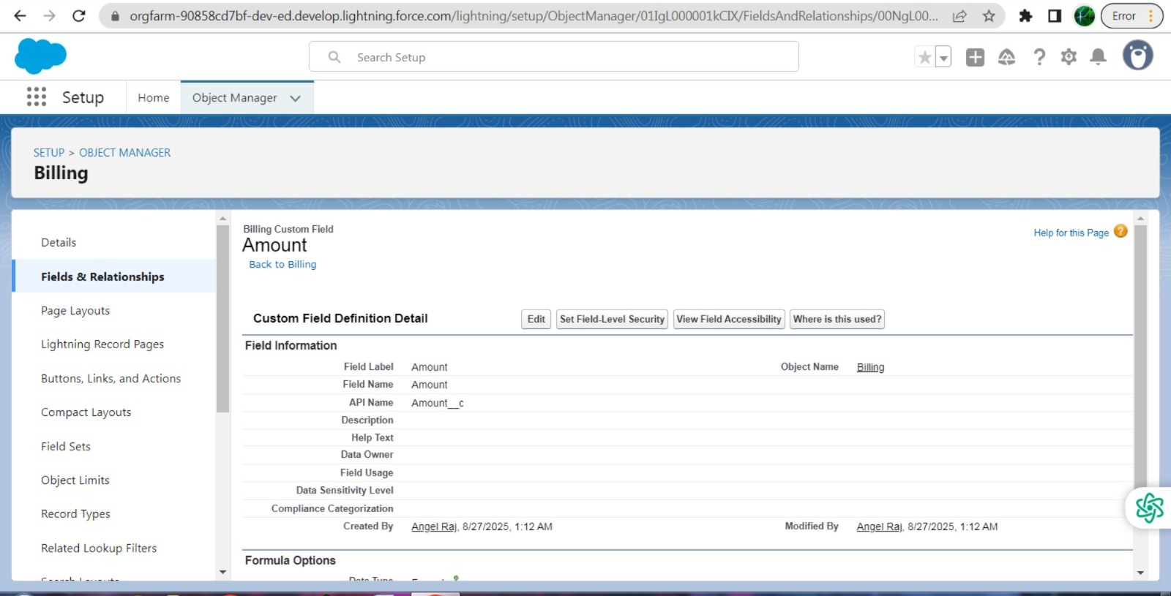

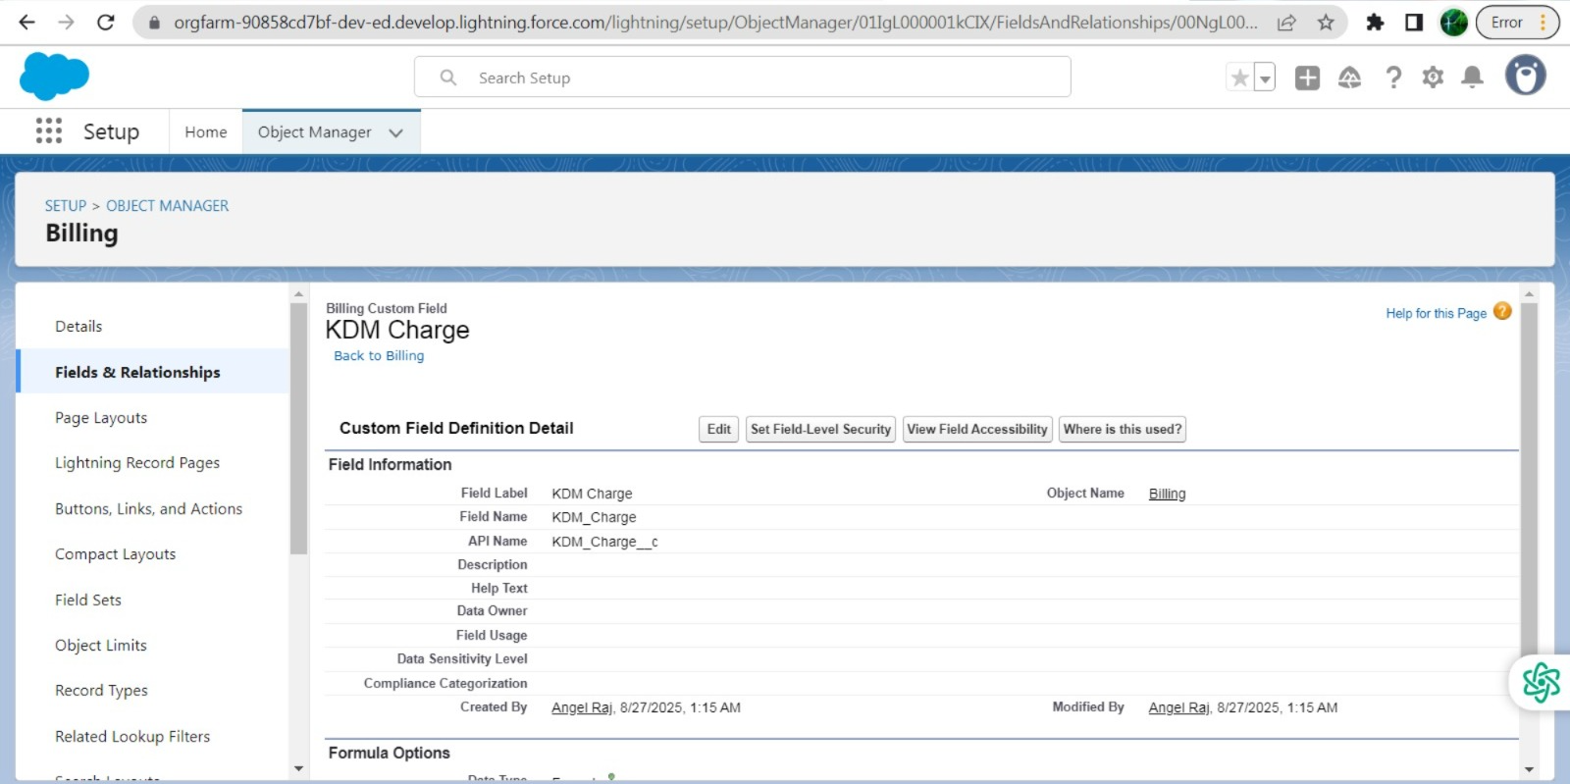

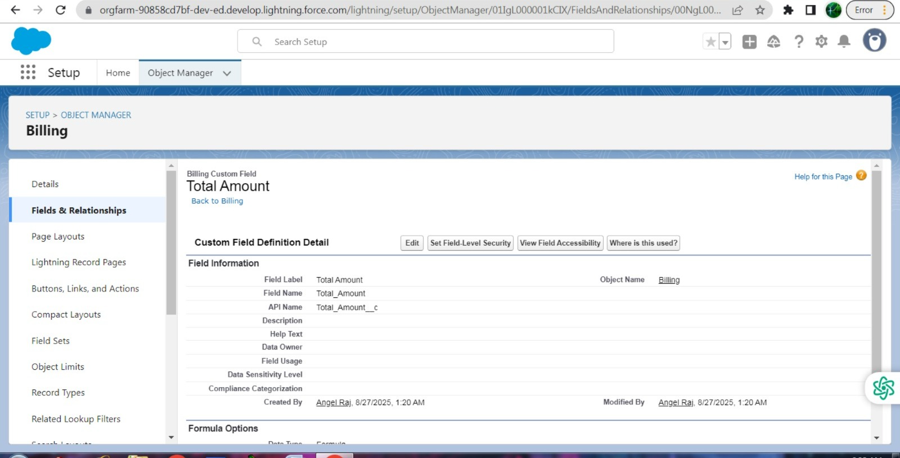

* Creating the Field Dependencies

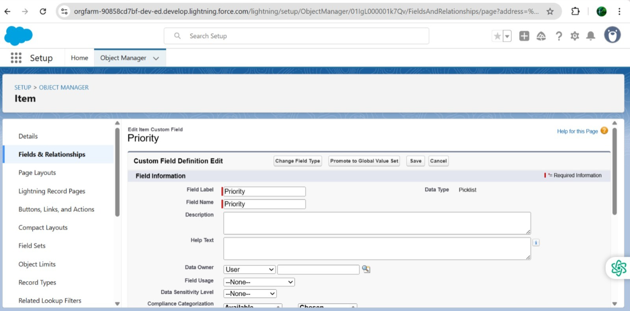

### Creating the validation rule

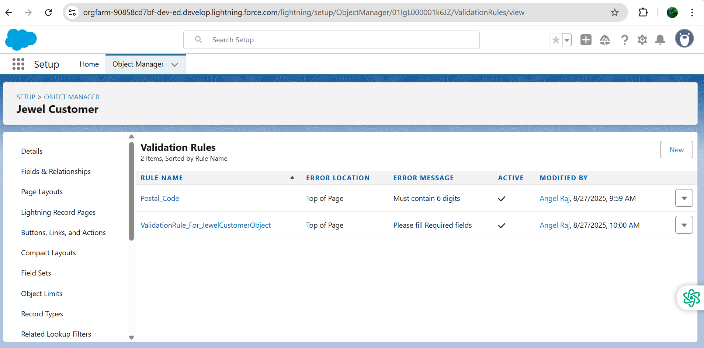

### Profiles

### Gold Smith Profile

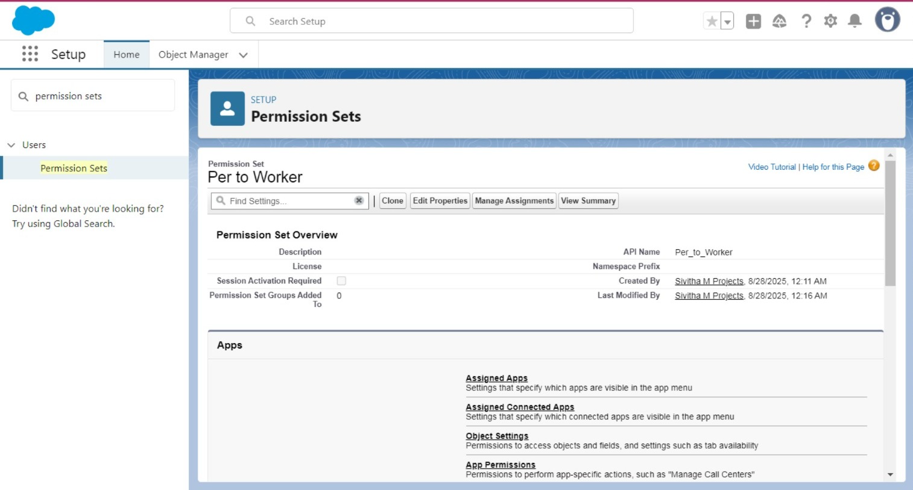

Page layouts

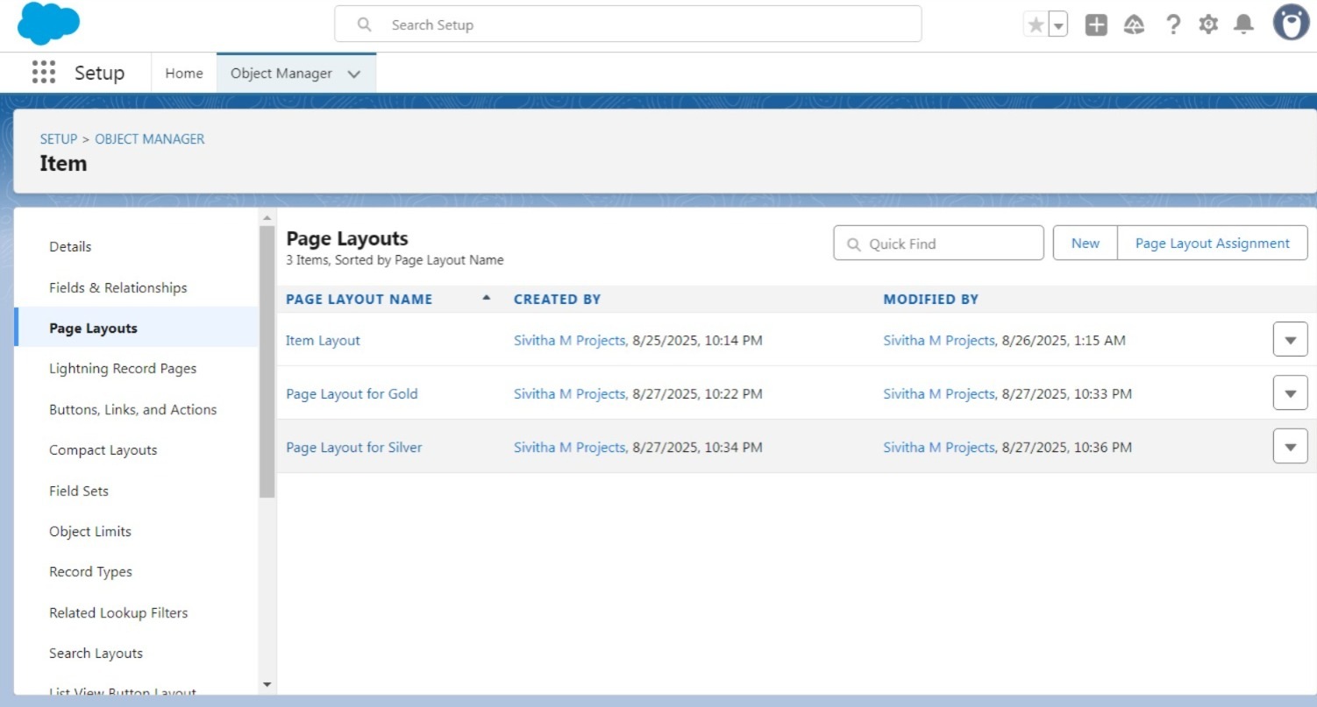

### Roles

### Creating Gold Smith Role and worker Role

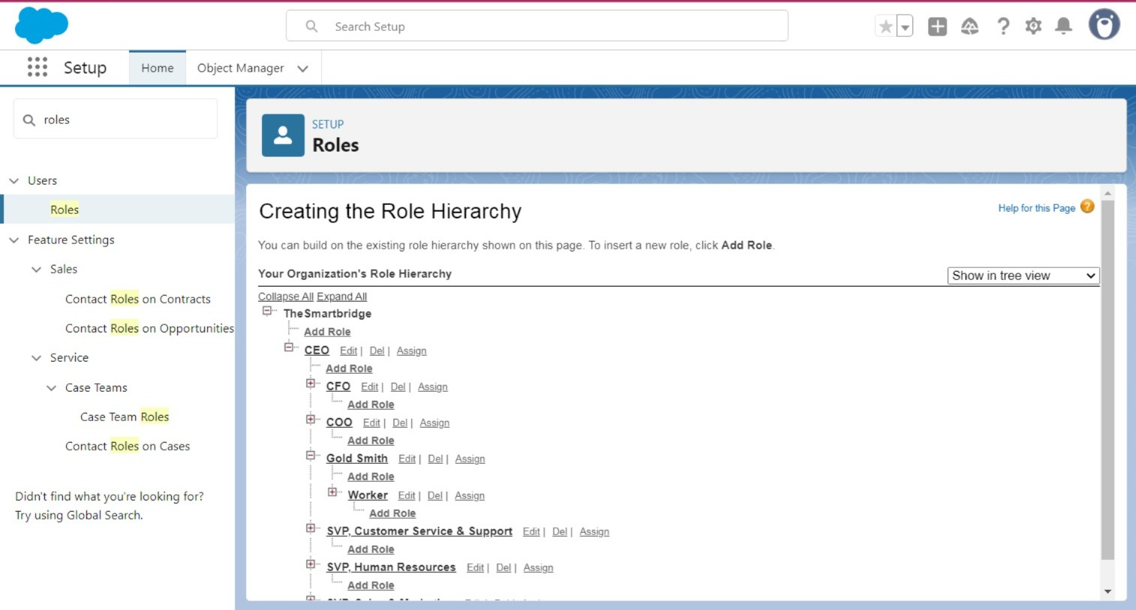

### Create Users

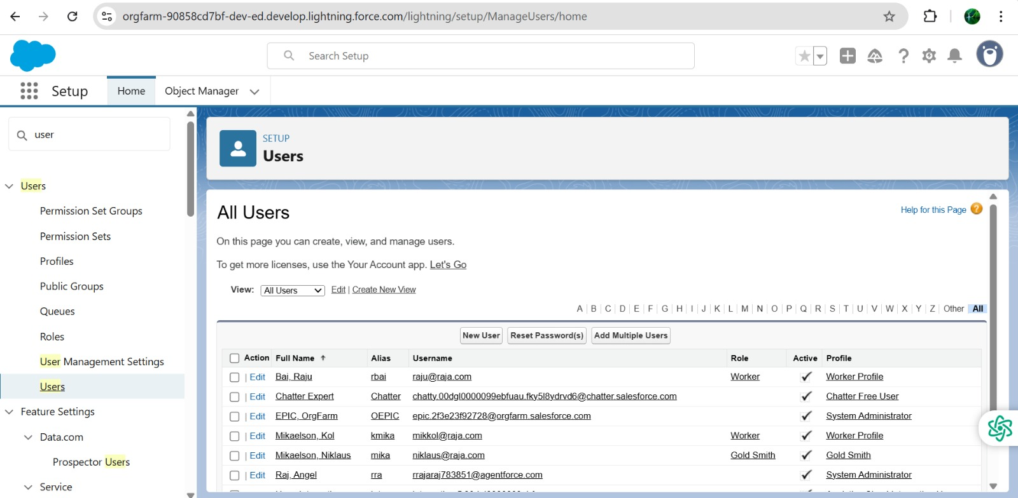

### Page layouts

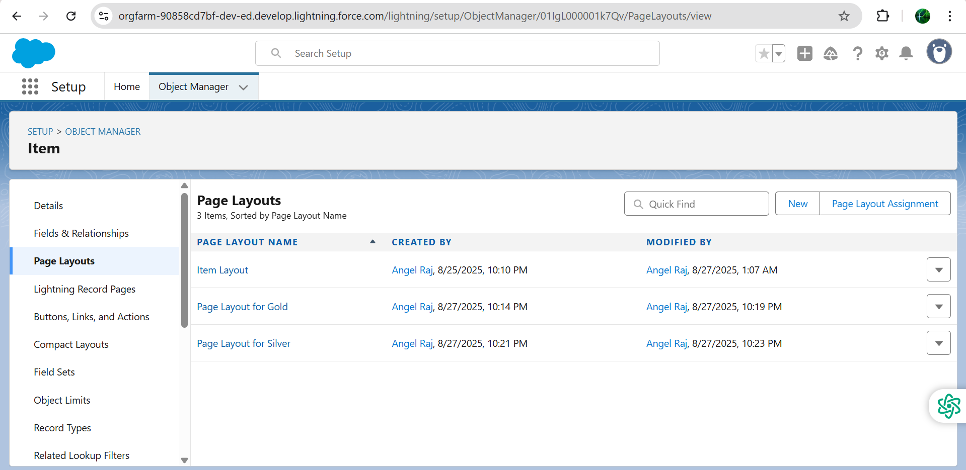

### To Create a Gold Page layout

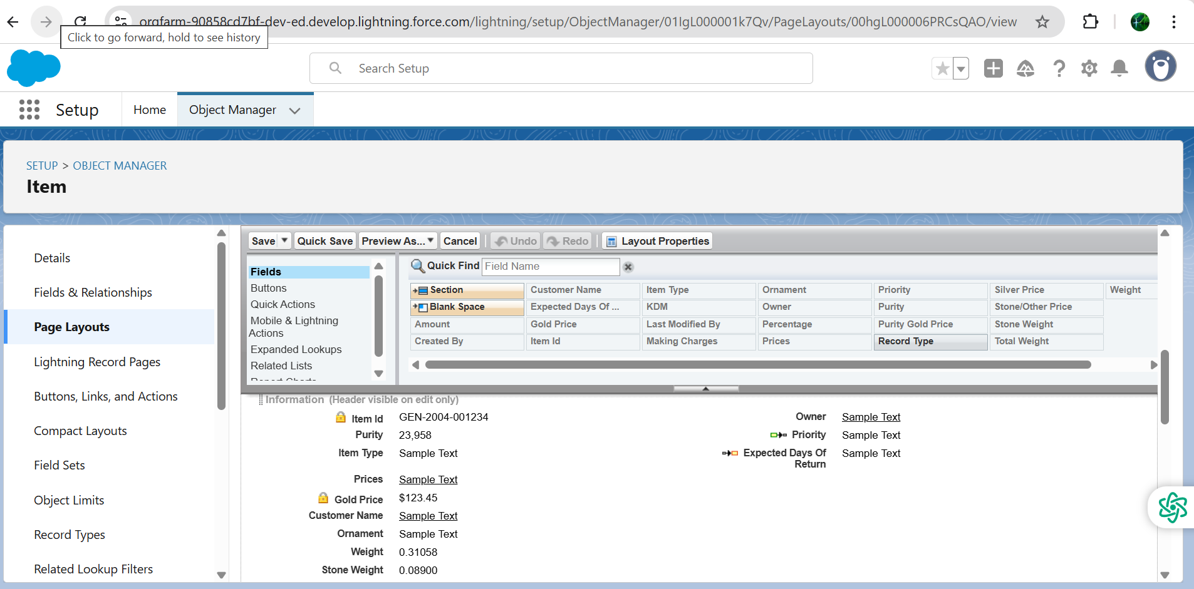

### To Create a Silver Page layout

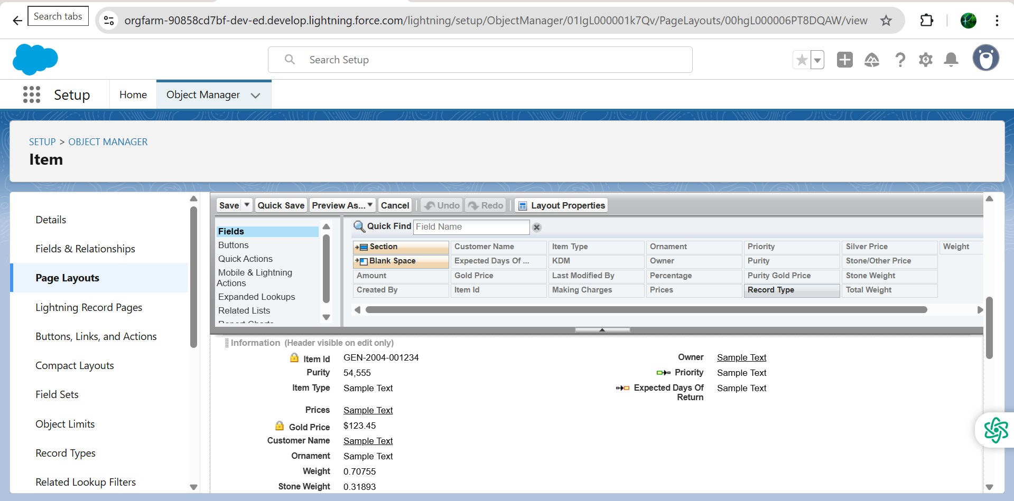

### Record Type

### To create a Record Type

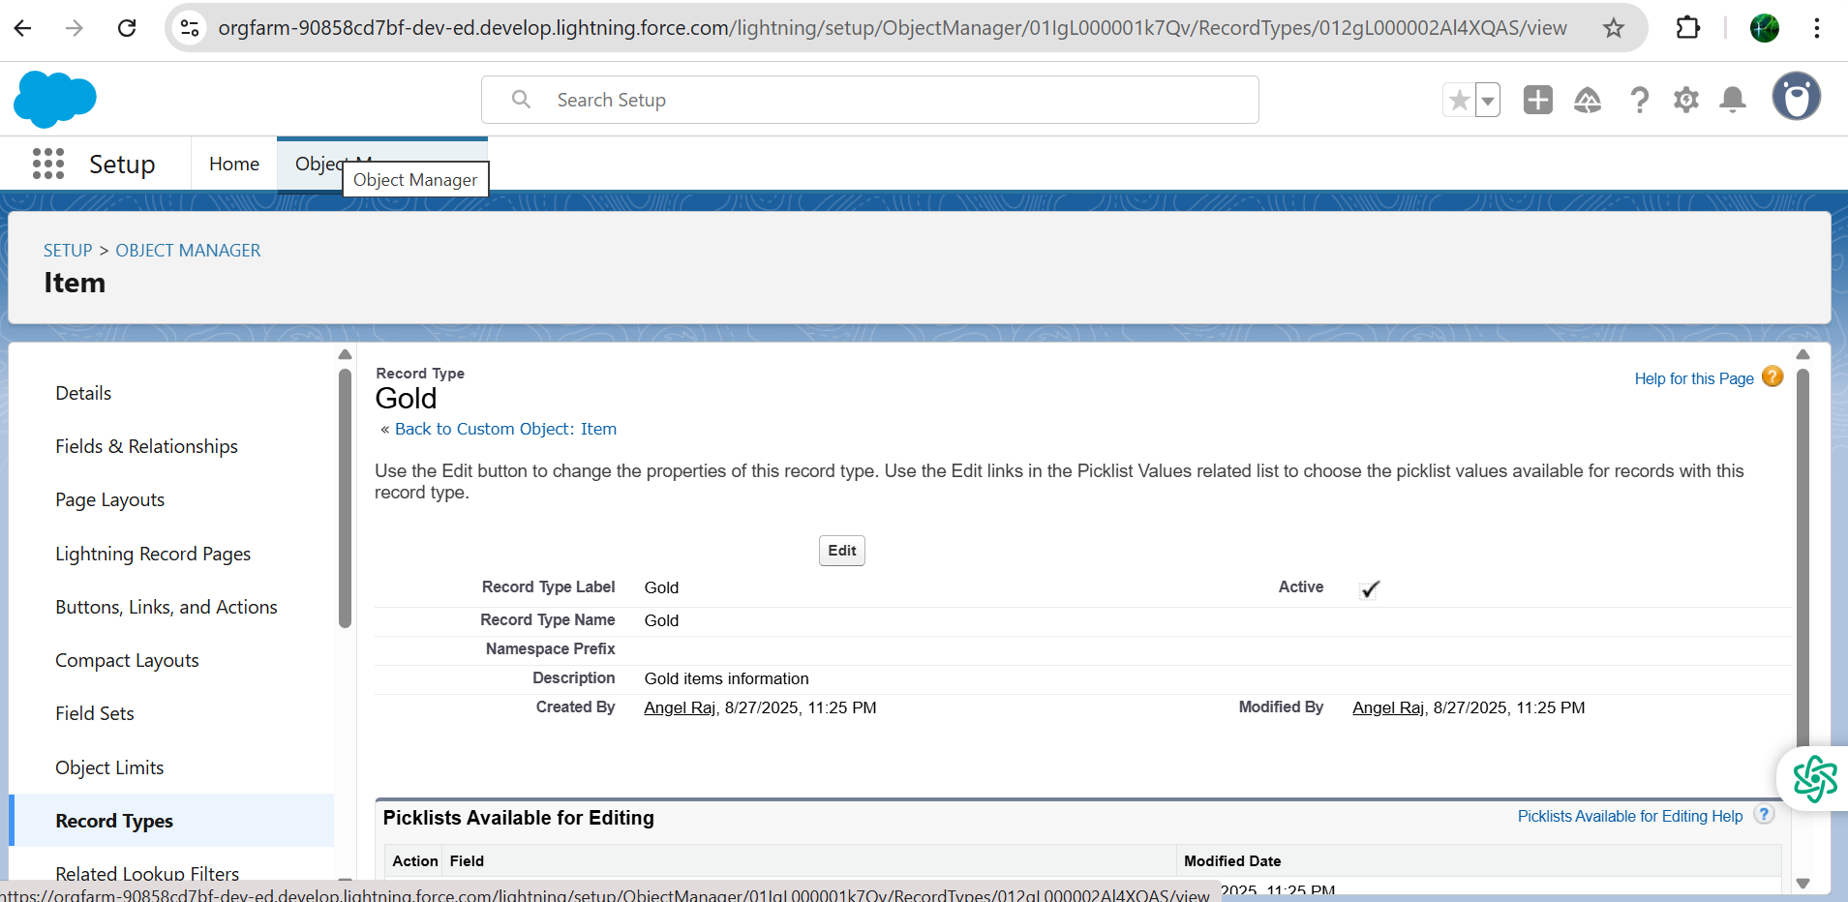

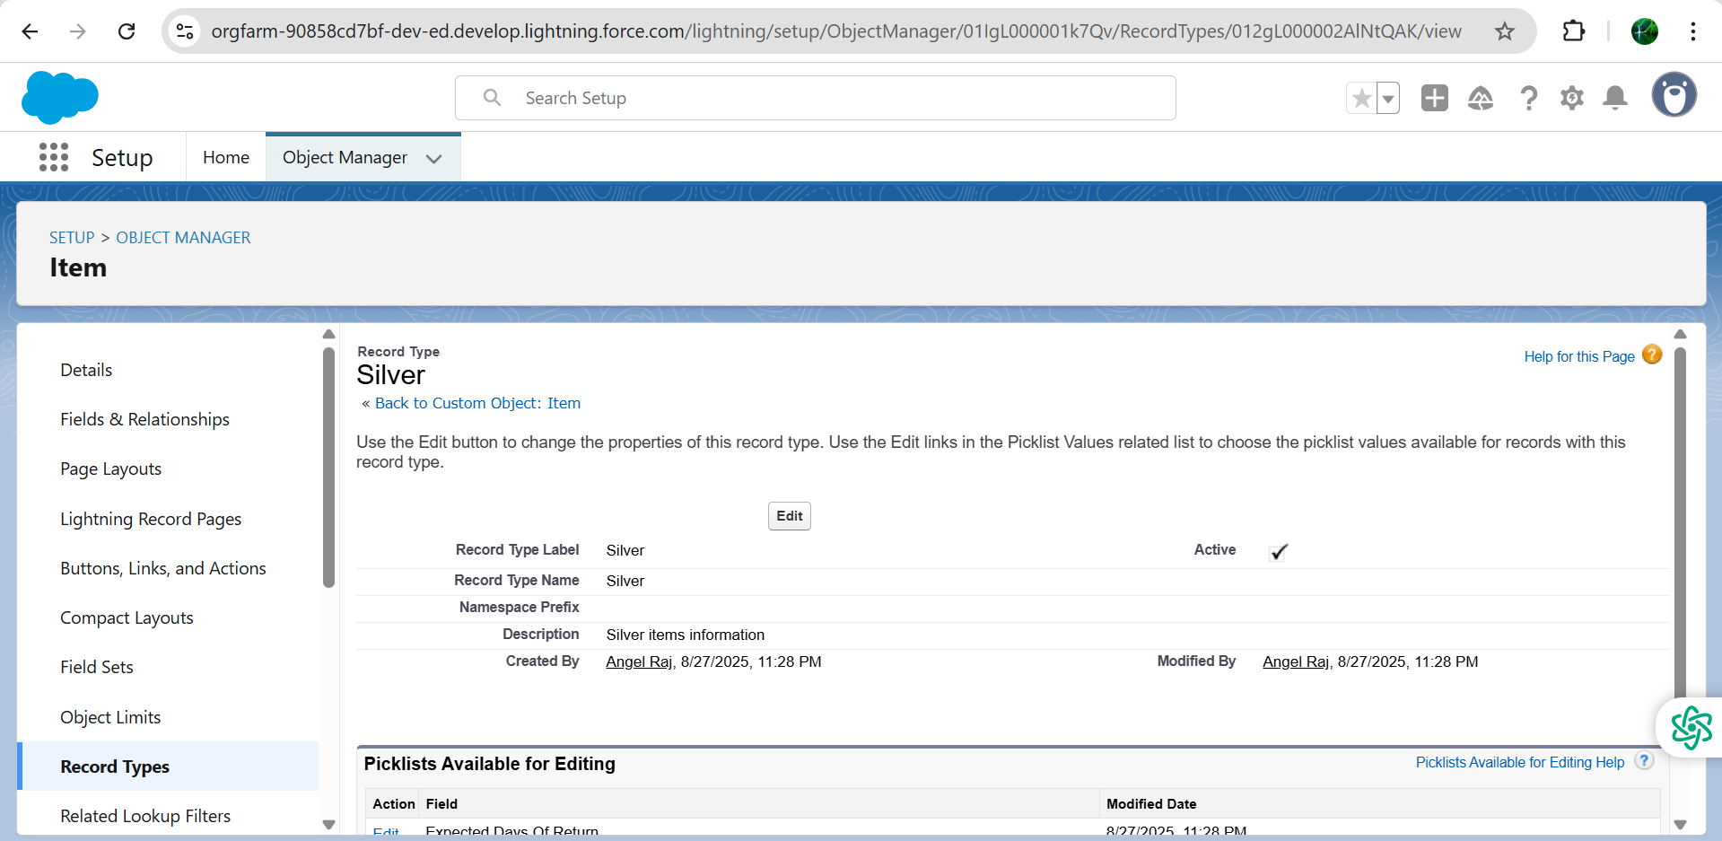

### Permission sets

### Creating permission set

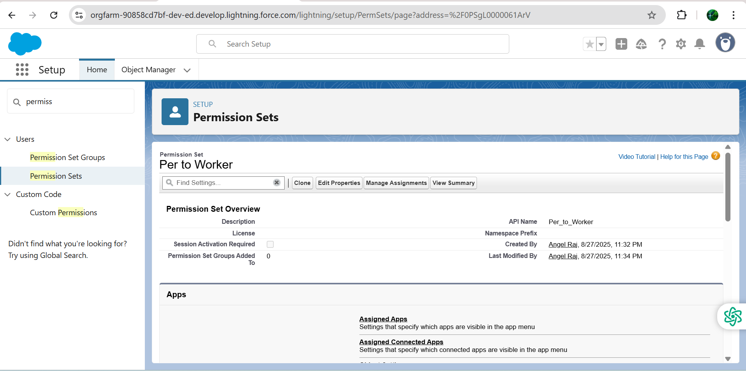

### Trigger

### Create a Trigger Handler class

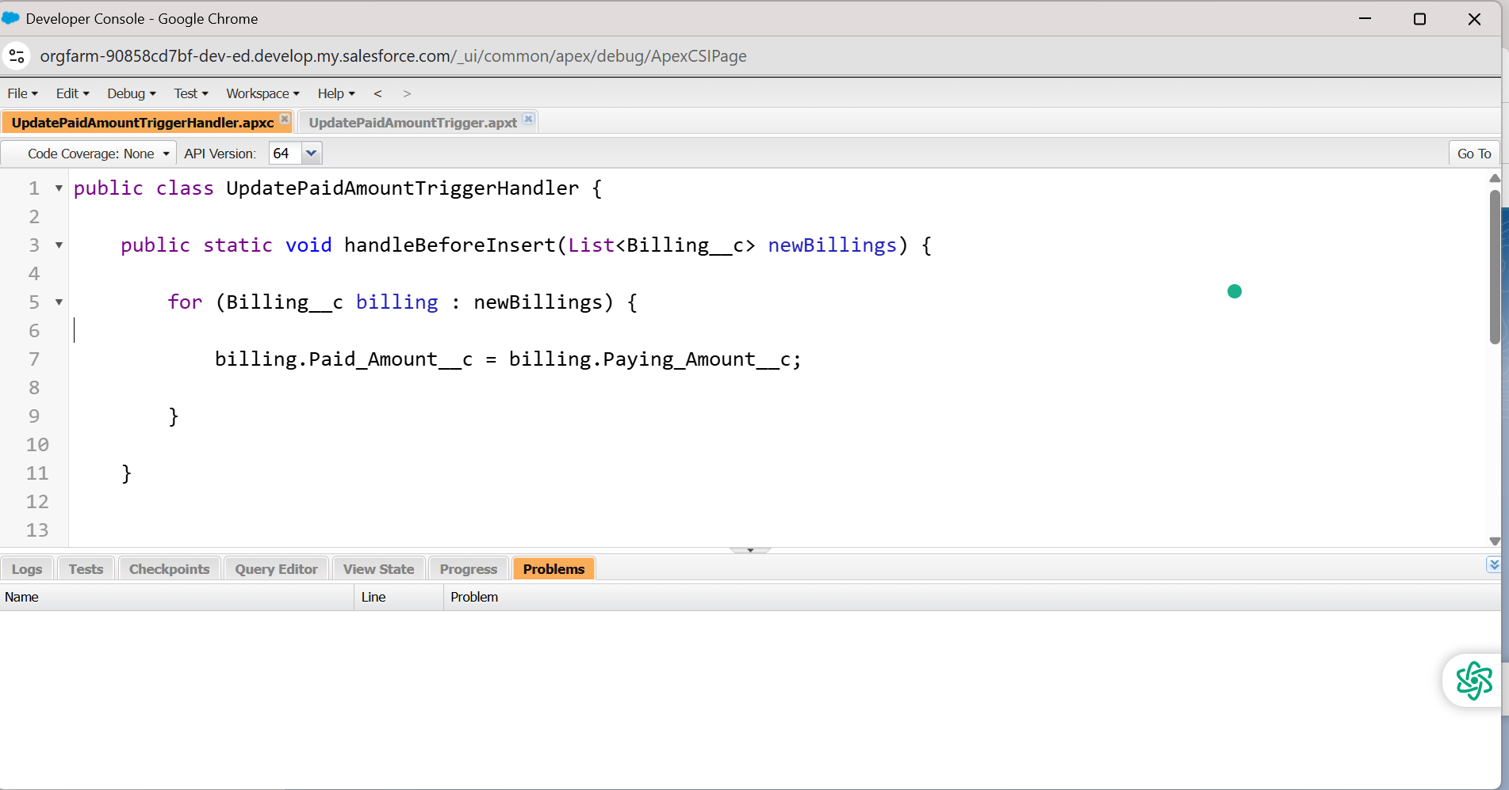

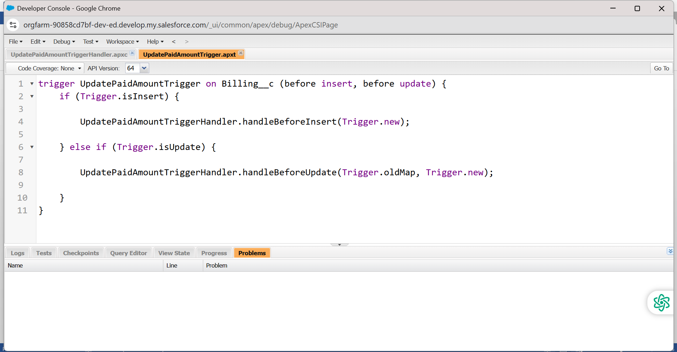

### User Adoption

### Create a Record

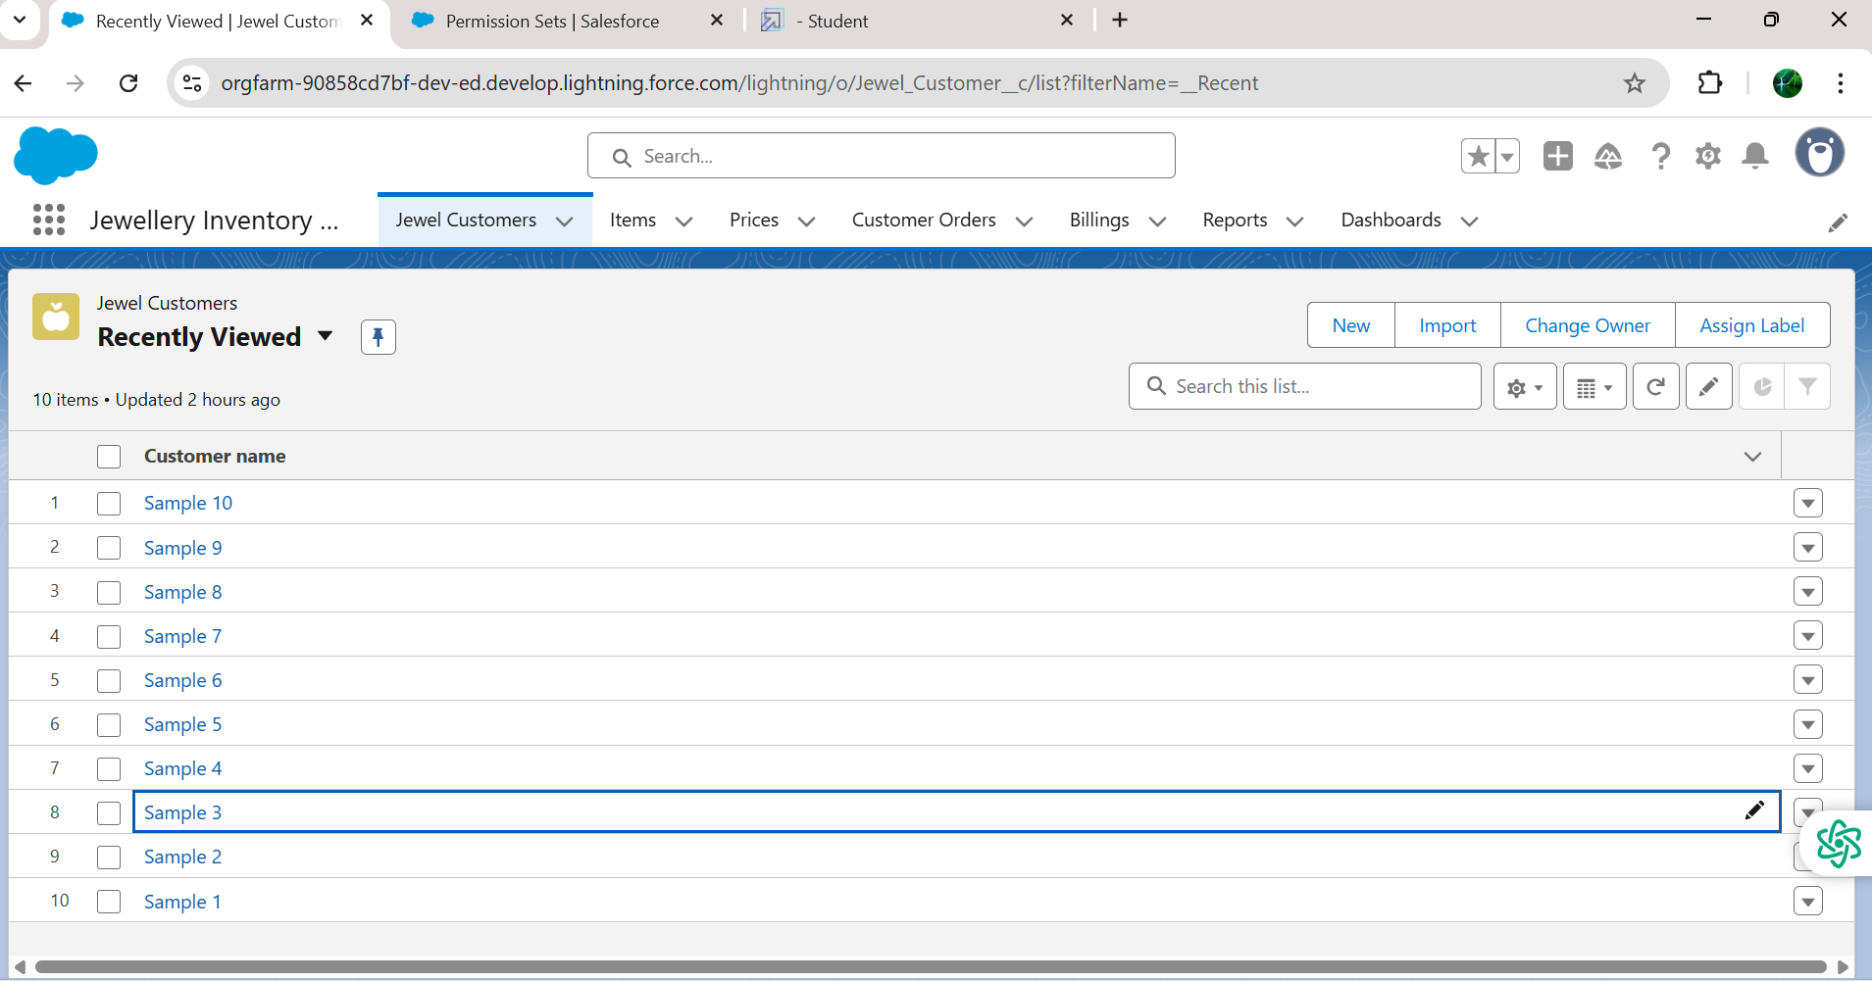

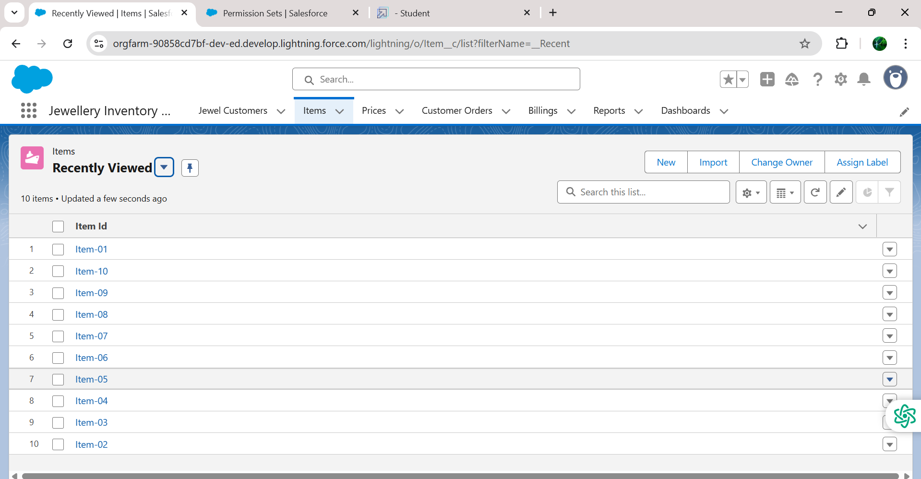

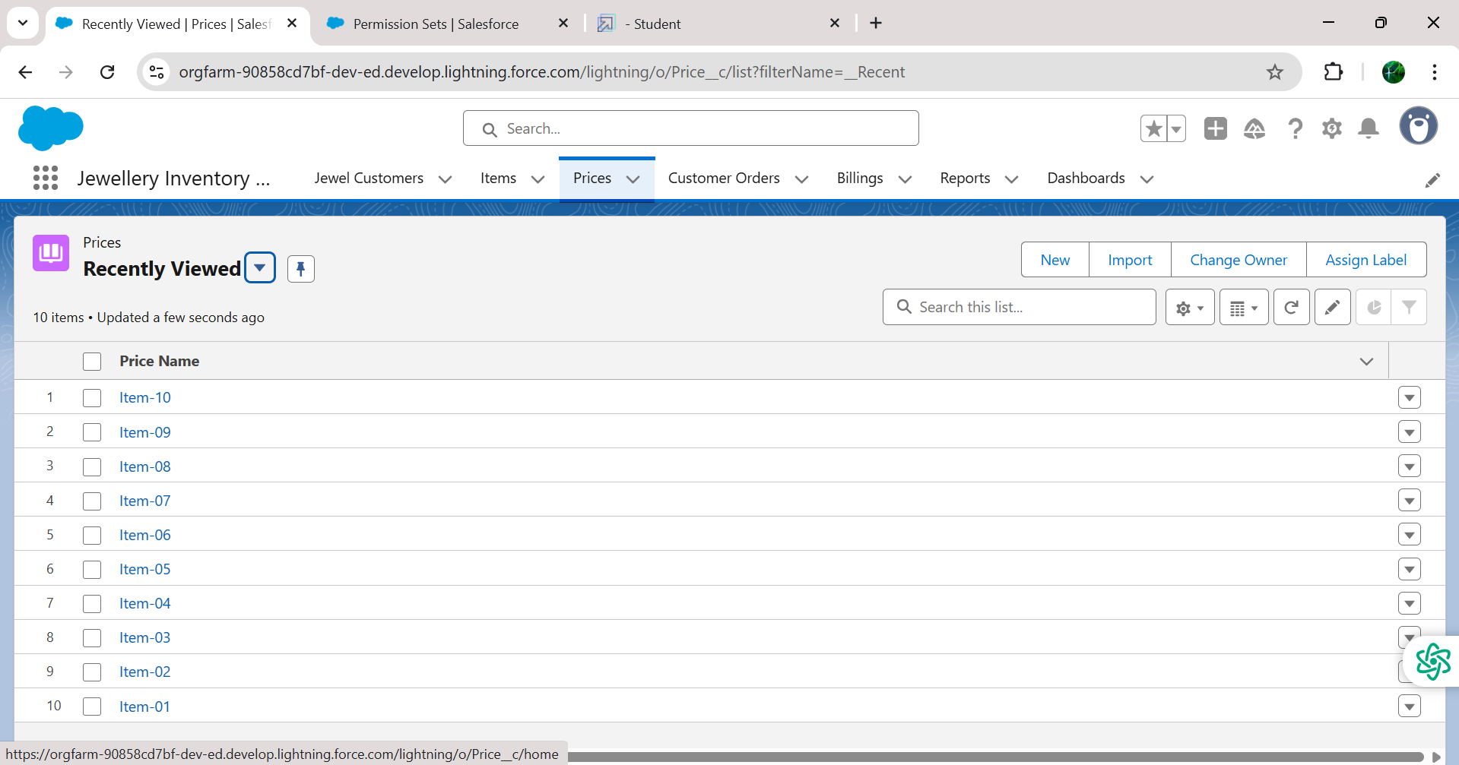

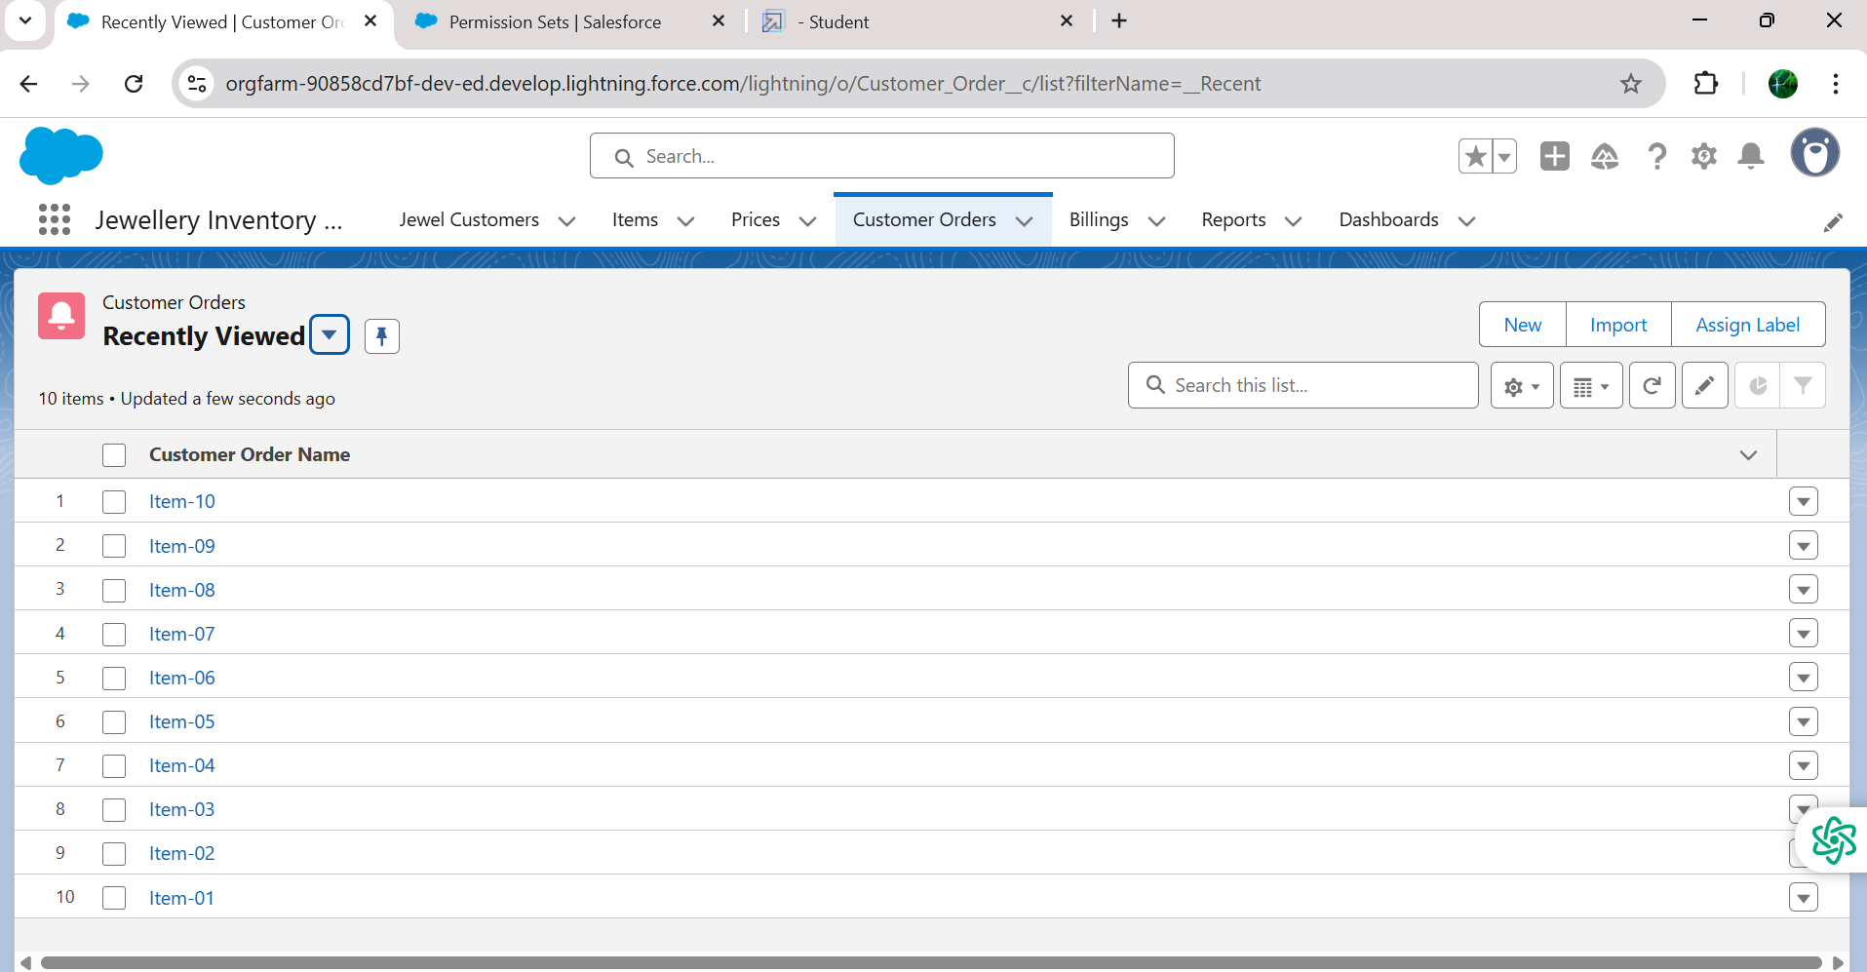

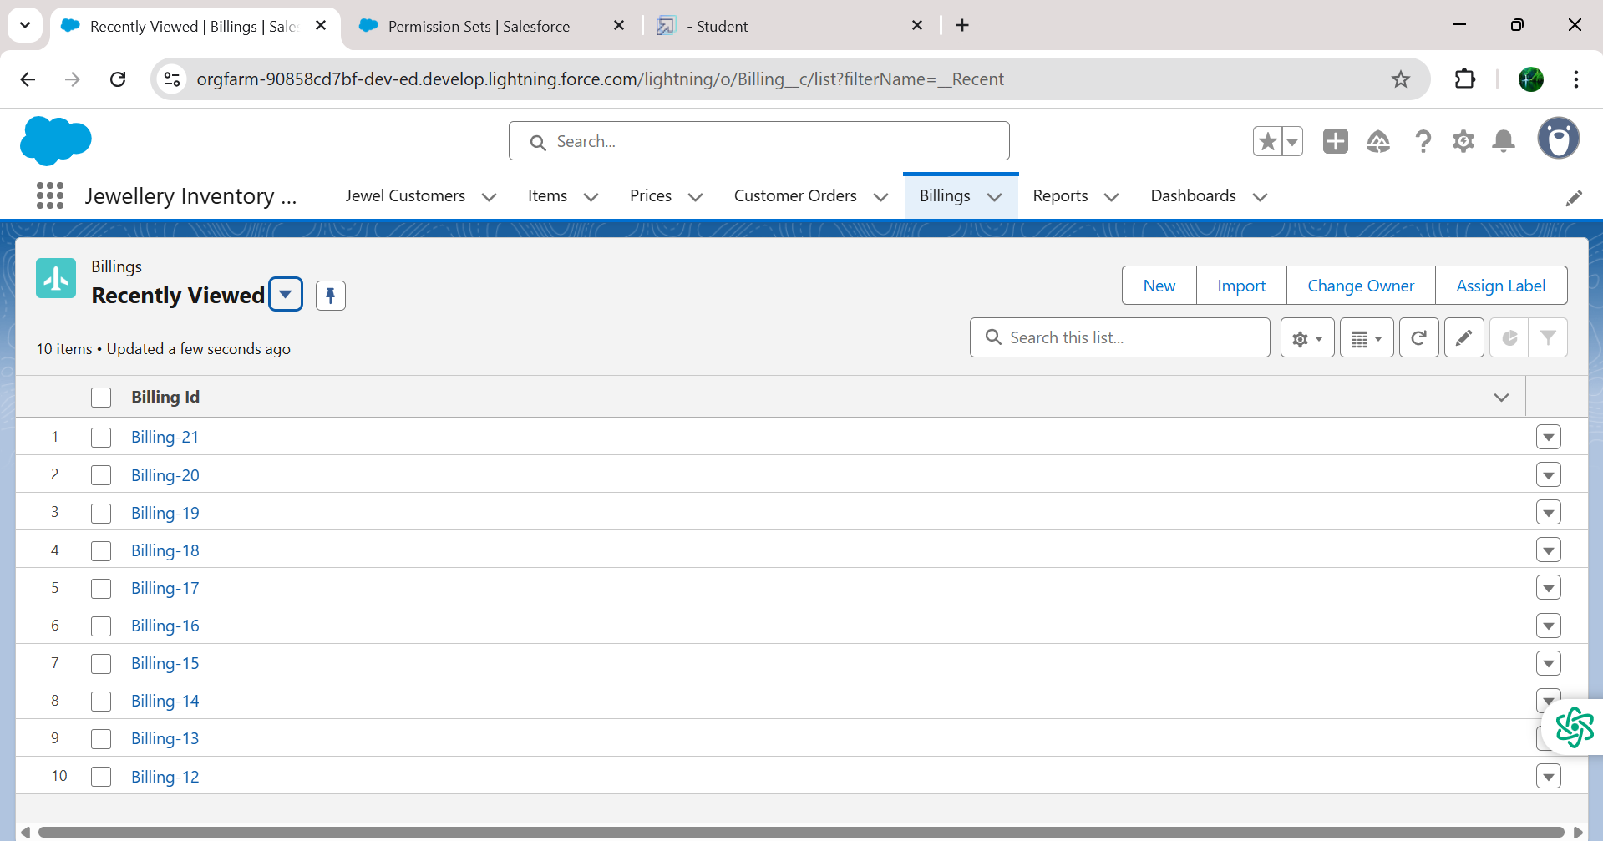

### Reports

### Create Report

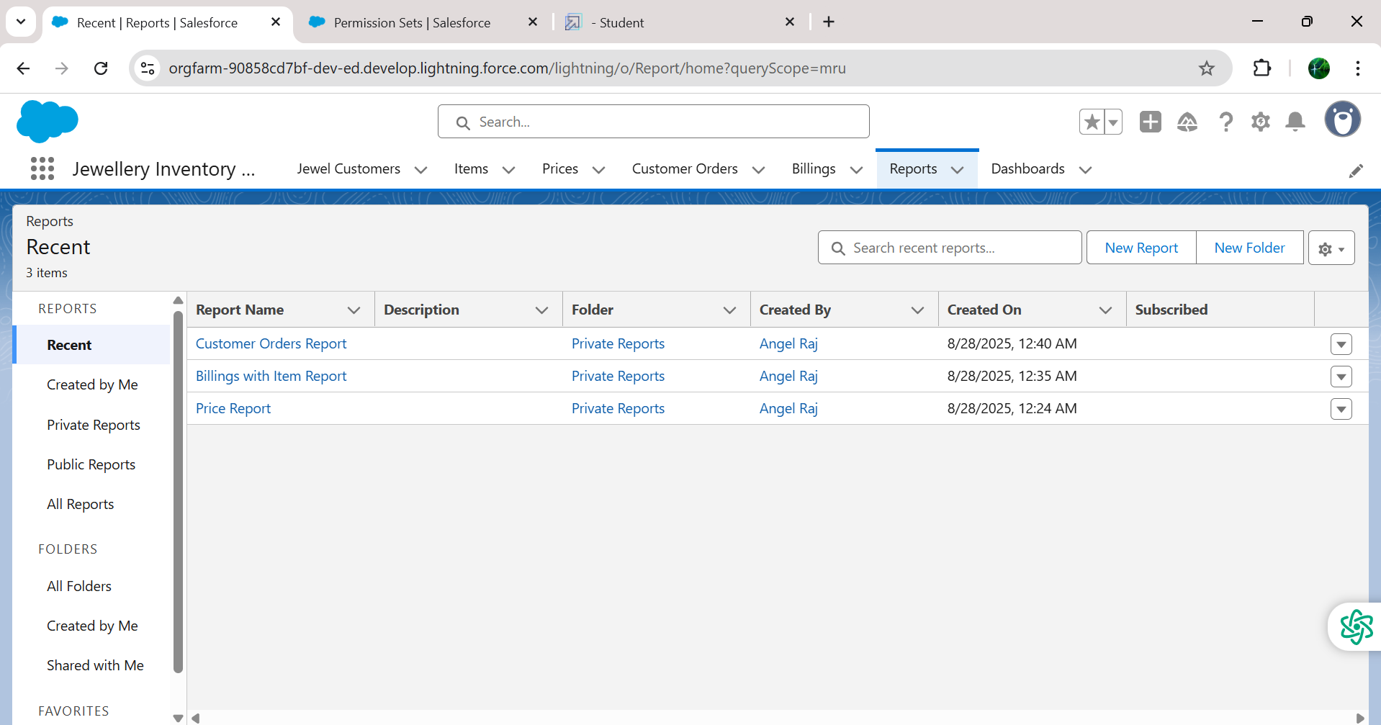

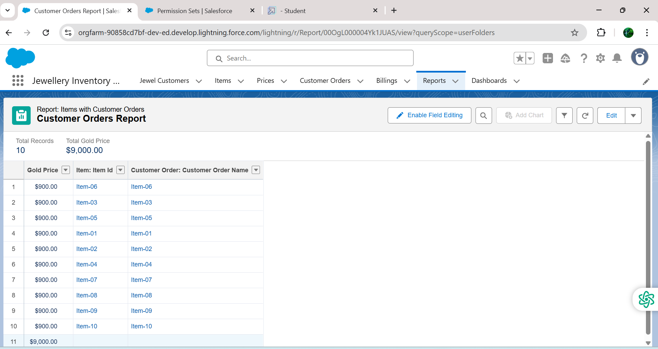

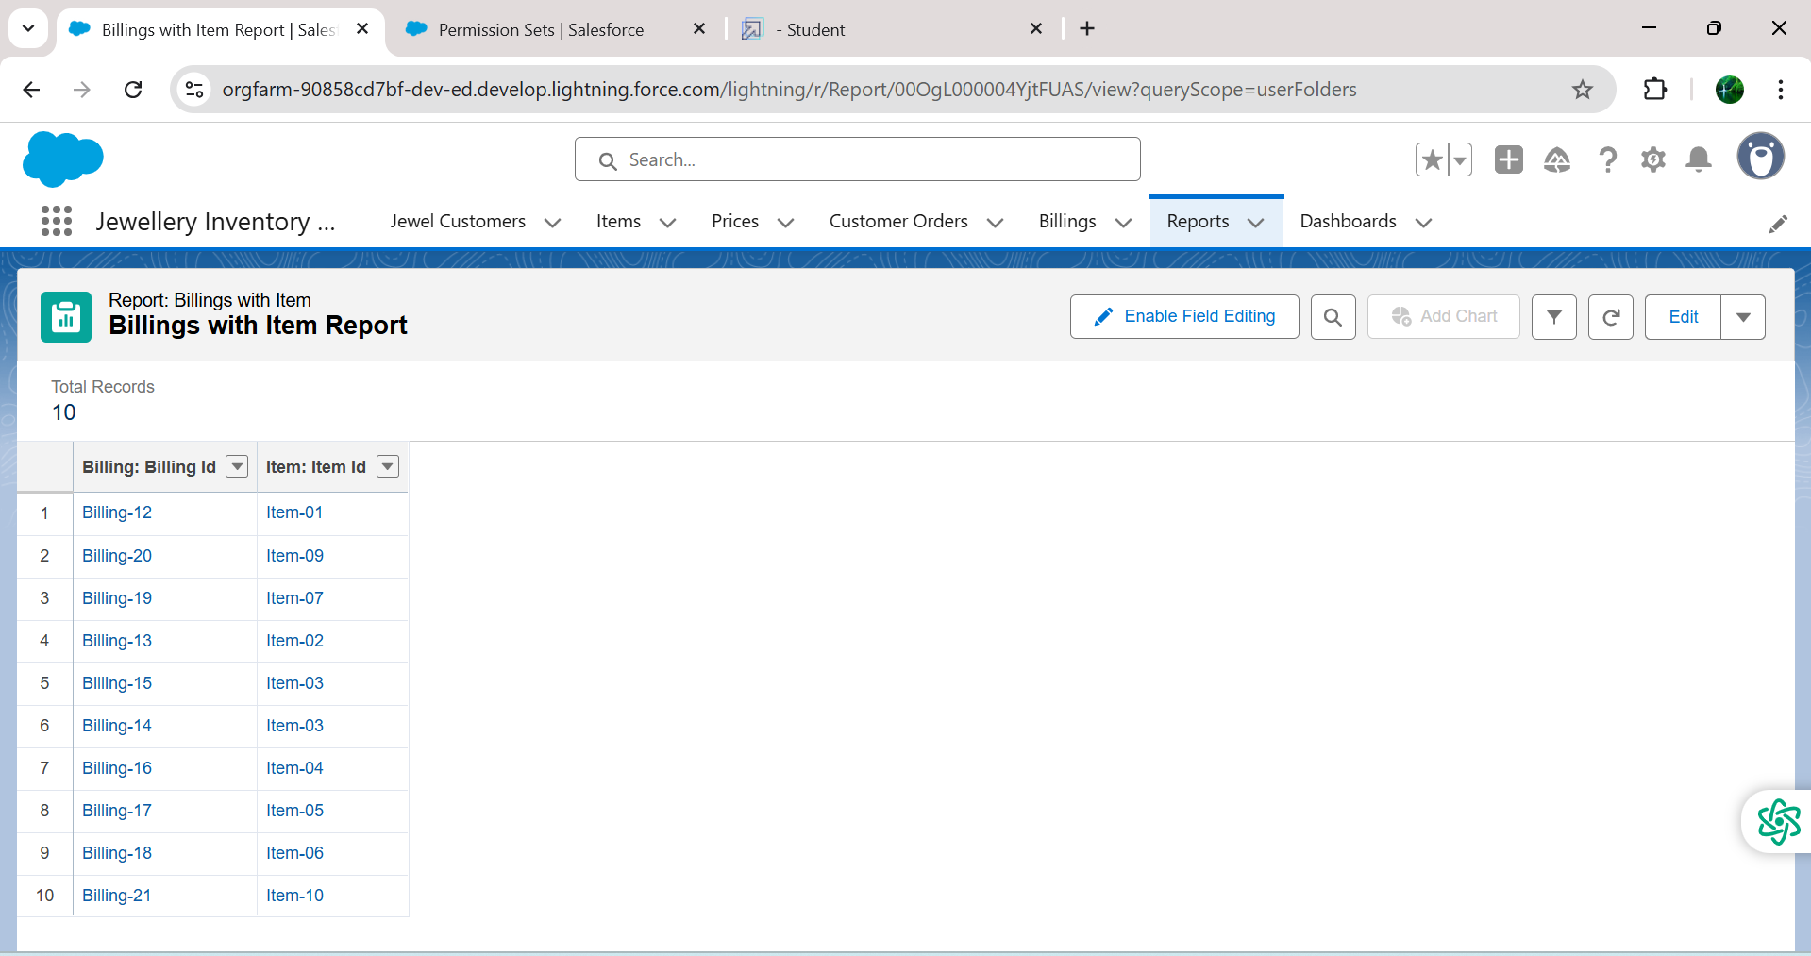

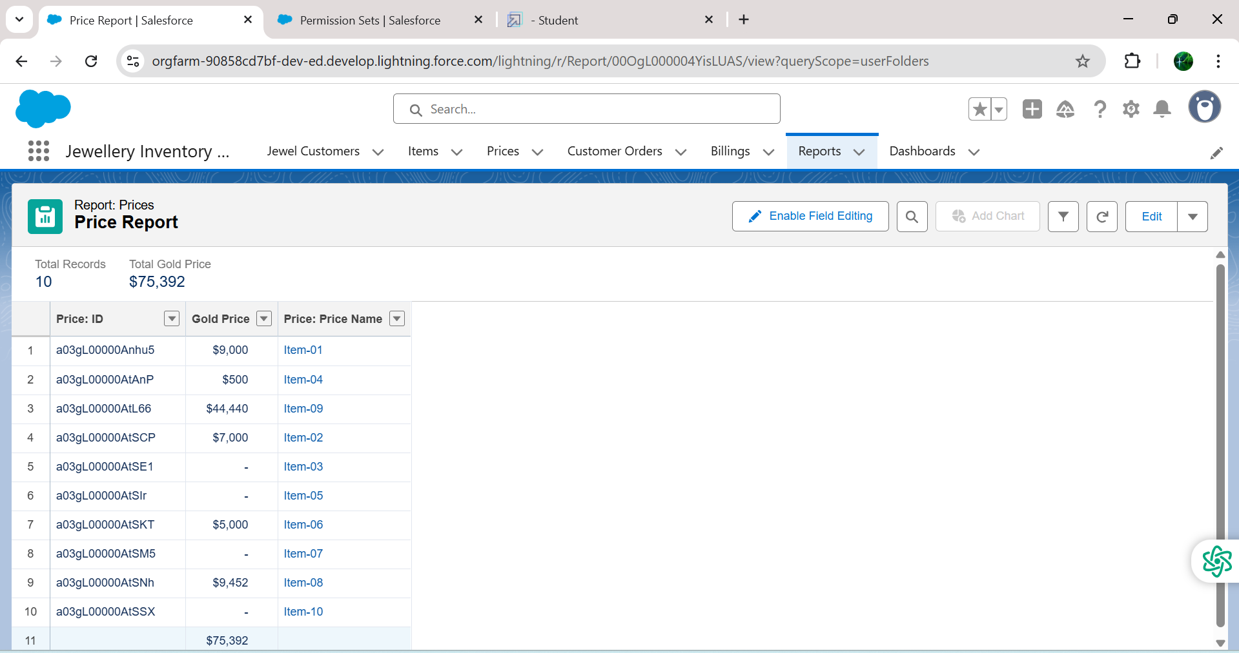

### Dashboards

### Create Dashboard

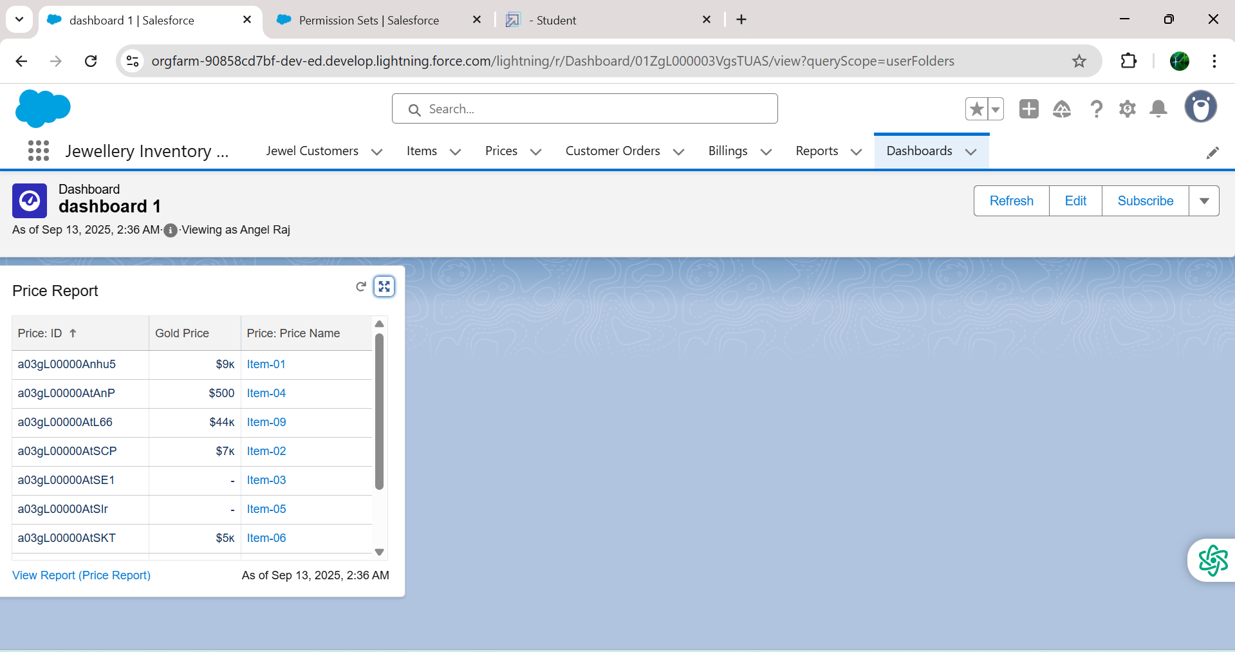

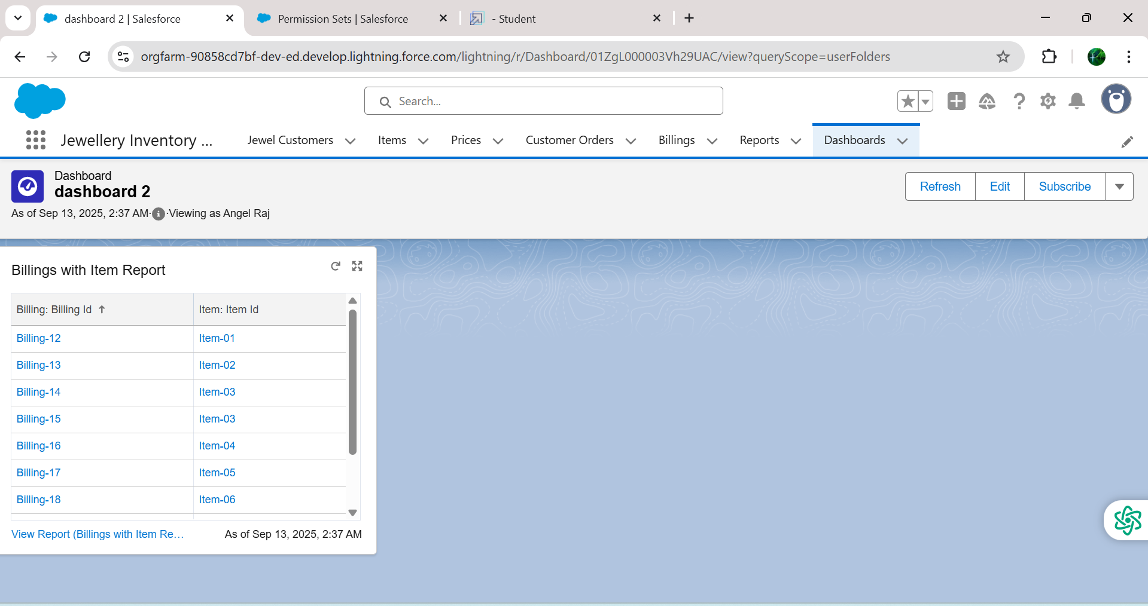

### Flows

### Create a Flow

